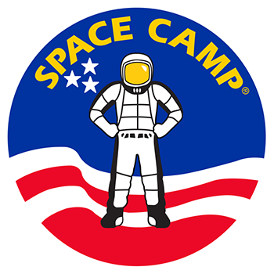
SPACE CAMP Application Form

Full Name (as it appears on passport):
Date of Birth:
Phone number:
Email Address:
Name of parent or guardian:
Contact details of parent or guardian:

Essay #1 (350-word limit)
How will attending Space Camp help you reach your future goals?

Essay #2 (350 word limit)
How do you plan to share what you learn at Space Camp with other youth in your school or community? Please add examples of leadership or mentoring you have done in the past.

Please include a copy of your passport, school transcript from 2019, along with the application to PDSuva@state.gov by March 31, 2020

