Fulbright Foreign Language Teaching Assistant (FLTA) Program
Instructions for Completing the
2024-2025 Fulbright FLTA Program Application

Application: https://apply.iie.org/flta2024
Read all instructions carefully before completing the application.

Contents
General Information 3
Creating Your Online Account 4
Managing Your Application 6
Welcome 7
Preliminary Questions 7
Country Information 9
Personal Information 10
Contact Information 11
Academic & Professional Information 12
Curriculum Vitae/Resume 12
Academic Background 12
Professional Experience 14
Awards and Recognitions 15
Experience Abroad 15
Previous Fulbright Grant 16
Academic Materials 16
Language Skills 17
English Language Proficiency 17
Additional Language Skills 17
Test Scores 18
Score Reports 18
FLTA Information 19
Language Skills 19
Preferences 19
Teaching Experience 19
Interests 20
Plagiarism Agreement 21
Essays and Objectives 21
Objectives and Motivations 21
Teaching Methodologies and Techniques 21
Sharing your Culture 21
Additional Information 22
Country-Specific Materials/Supplemental Materials/Additional Documentation 22
Other Grants and Awards 22
Outreach Survey 22
Authorization of Release of Information 22
Recommender Registration 23
Signature 24
Review 24

General Information

The application is supported by all modern browsers. We highly recommend that you use a current version of Google Chrome, which supports Windows, Mac, and Linux platforms.

Prior to starting an application, please complete the following steps:

Step 1: Learn requirements for submitting an application
Before you begin an application, contact the Fulbright Program Office in the country from which you are applying. Deadline dates and application requirements for a Fulbright grant will vary from country to country. You must make sure you are eligible to apply. Additional information and a list of participating countries can be found here: https://foreign.fulbrightonline.org/.

Step 2: Record username and password in a safe place
Your email address is your username. When you create an account for this online application, record your password in a secure place. You can log in and out of the application as frequently as you like using your username and password. If necessary, you can reset your password by clicking the “Forgot Your Password” link on the log-in page.

Step 3: Complete the application
You do not need to complete this application at one time. You can re-enter at any time to edit your application. However, once you SUBMIT your application, you CANNOT make changes to it.

To complete your application correctly, please answer all questions completely and carefully. Review these additional tips:
- Use upper and lower-case letters (e.g. John Smith). Avoid using all capital letters (e.g. JOHN SMITH). Do not use special characters, such as accent marks.
- You can copy and paste information into all text boxes.
- Limit your responses to the space provided in all text boxes.
- Prepare required documents and save them in PDF format. It is highly recommended that to preserve any formatting and special characters in your documents, you upload them in PDF format.
- Some questions are “required.” They are marked with an asterisk (*). You will not be able to submit your application until all required items are complete.

Step 4: Submit the application
Once you have entered all required information, including recommenders, review your application for errors. If all information is correct, submit your application. Once you submit you CANNOT make changes to your application.

Creating Your Online Account

- To start, click Create an account.

- Enter your email address, first name, last name, and select your date of birth (Month-Date-Year) from the drop-down menus. Your name must be entered exactly the way it appears (or will appear) on your passport.

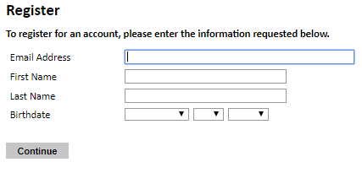
Note: Use an email address that you will be able to access for at least two years after submitting your application. This is the email address you will use to log in to your application account. We recommend you do NOT use a work email address if you will not have access to it during your grant in the U.S.

- Click Continue. You will receive an email from apply@iie.org confirming that you have started the application. The email will include a temporary PIN. Follow the instructions in the email to activate your account using the temporary PIN.

- You will be prompted to enter your pin and then create a password to complete login.

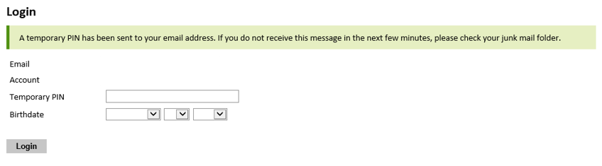

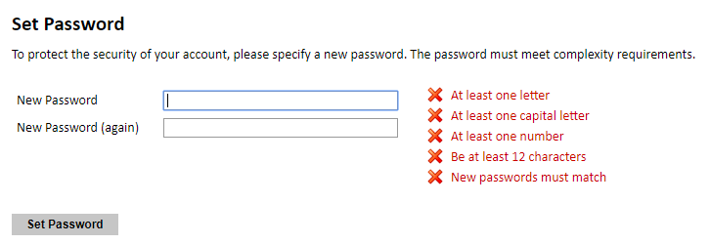

- Returning users: Click Log in and enter your email address and password. If you do not remember your password, click Forgot your password? and follow the resulting instructions.

Managing Your Application

Editing your application prior to submission

- You may log in at any time to review and edit your application form, upload documents, and enter recommender information.

- Remember to save your application after completing each page by pressing the Continue button at the bottom of each page.

Note: The application will automatically log you out after 60 minutes of inactivity, so it is best to save your application frequently.

Reviewing your application after submission

- After you SUBMIT your application, you CANNOT make any changes.

- You may continue to log in to your account to view the information you have submitted, save a PDF of your application form, and manage your recommenders.

- You can manage your recommenders by clicking on the Recommendations section of the online application.

letters of recommendation

- Letters of recommendation will be submitted directly to Fulbright by the recommenders you registered via your application.

- Letters of recommendation and language evaluations may be submitted before or after you submit the application.

- The letter of reference must be written by a teacher under whom you have studied or pursued research in the proposed field of study or by someone who has supervised you in work related to expected program responsibility. This letter should be typewritten and written in English. If not in English, then an accurate translation must be attached.

- If your recommender is unavailable, you will have the option to exclude the recommender and add an alternative after you submit the application.

Welcome

Review the information provided including the Fulbright Policy Guidelines.

You must select ‘Yes’ to confirm you have the read the Fulbright Policy Guidelines.

Click Continue to save your response and advance to the next section.

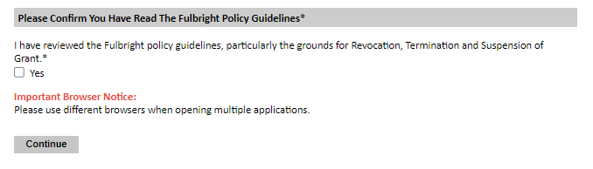

Preliminary Questions

These questions address essential program eligibility. All questions are required.
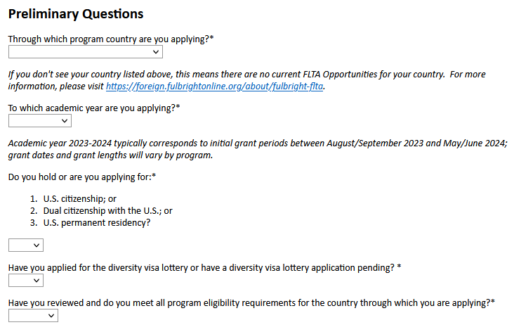
- Select the country through which you are applying for the Fulbright grant from the dropdown menu.

- Select the appropriate program year from the dropdown menu.

- U.S. Citizenship, Dual Citizenship with the U.S. or Permanent Residency: select ‘Yes’ or ‘No’ to indicate your response.
  - U.S. citizens or permanent residents of the U.S. are ineligible to participate in the Fulbright Foreign Language Teaching Assistant Program. Applicants who select ‘Yes’ will not be able to view the application.

- Select ‘Yes’ or ‘No’ to indicate where you have applied for the diversity visa lottery or have a diversity visa lottery application pending?
  - Applicants who select ‘Yes’ must indicate in the provided text box details regarding their diversity visa lottery application. Applicants should state when the application was submitted, the type of application submitted, the purpose of the application and the application’s current status.

- Select ‘Yes’, ‘No’, or ‘Unsure’ to indicate if you are aware and meet all program eligibility requirements.
  - Please review the program eligibility requirements for the country through which you are applying before proceeding.

- Carefully review the provided IIE Data Privacy Consent information. Indicate your acceptance of the data privacy terms by selecting ‘Yes’ or ‘No’.
  - You will not be able to submit your application without indicating your agreement to the Data Privacy terms.

- Select ‘Yes’ or ‘No’ to indicate if you meet all employment eligibility requirements.
  - Applicants or applicants’ immediate family cannot have been employed by the stated organizations and/or agencies within the year prior to application.
  - If you select ‘Yes’, please provide details of employment or association.

- Select ‘Yes’ or ‘No’ to indicate if you will waive your right to review the information contained in evaluations submitted by recommenders.

- Click Continue to save your responses and advance to the next section.

Country Information

- Review all information in this section.

- Note any country-specific instructions for completing the rest of the application, including:

  - Country Website: https://iq.usembassy.gov/fulbright-foreign-language-teaching-assistant-flta-program/
  - Application Instructions: https://iq.usembassy.gov/fulbright-foreign-language-teaching-assistant-flta-program/
  - Deadline for Iraq: May 13, 2023

- Click Continue to proceed to the next section.

Personal Information

Enter all required biographical information. Please review country-specific guidance (provided in the Country Information section of the application) to determine whether you must provide additional information.

- Enter your name exactly as it appears on your passport. Only enter a preferred name if it is DIFFERENT than your legal name (e.g. Alex instead of Alexander).

- If your name is recorded differently on any previous records, list it in the Name on Previous Records section (e.g. maiden name).

- The birthdate that you used to create your account will automatically appear. If you entered this date incorrectly during your account creation, you may correct it now.

- Enter your city of birth and select country of birth, sex (as it appears or will appear on your passport or travel document), preferred gender identity, and marital status from the dropdown menus provided.

- Enter number of dependents. Please review the FLTA Program’s policy on J-2 visa sponsorship for dependents: select ‘Yes’ or ‘No’ to indicate your response.

- Please indicate any limitations you may have that require accommodations. The Fulbright Program complies with the Americans with Disabilities Act (the “ADA”) and is committed to diversity and inclusion. This information is gathered for statistical purposes and to ensure appropriate accommodation at a prospective host institution.

- Select your country of citizenship and country of residence from the dropdown menus provided. To select indicate additional countries of citizenship, hold down the CTRL (PC) or Command (Mac) button when selecting options.

- If applicable, enter your national identification number and any additional countries in which you hold citizenship.

- Click Continue to save your responses and advance to the next section.

Contact Information

Enter all required contact information. Please review country-specific guidance to determine whether you must provide additional information.

- Select the country where you live from the dropdown list first when entering your permanent address (i.e., physical address where you live).
  - Based on your country selection, the subsequent fields will change to match the address format of that country.
  - Complete the remaining address fields. Do not use accents or special characters.

- Select ‘Yes’ or ‘No’ to indicate if your current mailing address (i.e., the address where you receive mail) is the same as the permanent address you entered above. They do not have to be the same.
  - If you answer ‘No,’ then a second address section will appear where you may enter your mailing address information.
  - If you answer ‘Yes’ to this question, proceed immediately to the next question.

- Enter your contact numbers as appropriate. Include the country code. If the field turns red, please review the numbers that you have entered to look for any errors.
  - To find the correct country code, click on the blue ‘country code’ link.

- The email address used to create your account will appear in the primary email address field and will not be editable. You may provide an Alternate/Secondary Email that can be used to contact you if Fulbright Program Officers cannot reach you via your primary email address.
Note: All system-generated emails will continue to go to your primary email address.

- Enter your home country emergency contact information. The individual(s) you list may be contacted in the event of an emergency while you are participating in grant activities, including any required travel for interviews in your home country.

- Entering emergency contact information in the United States is not required. If you have emergency contact(s) in the United States at this time, please enter the appropriate information.

- Click Continue to save your responses and advance to the next section.

Academic & Professional Information

This section collects information about your academic and professional background, including your curriculum vitae/resumé, academic degrees, professional experience, awards and recognitions, and experience abroad.

Prepare and upload documents in PDF format as required (*). Note any page limits and ensure your documents do not exceed page limits.

Curriculum Vitae/Resume
- Upload your curriculum vitae/resumé in PDF format that does not exceed four (4) pages.
Note: If your file exceeds 4 pages, an error message will appear on the Review page and will prevent submission of your application.
- Click Browse.
- Locate and select the file that you previously saved to your computer.
- Click Open.
- Click Upload to complete the file upload.

Academic Background
- List all post-secondary educational institutions you have attended for credit-bearing coursework, in reverse chronological order, including any in which you might be presently enrolled. Do not include any short-term certificate programs. Short-term certificate programs can be noted on your CV/Resume.
  - Click Add New Academic Background.
  - Type in the name of the institution.
  - Choose the level of study (graduate or undergraduate) from the dropdown menu.
  - Select the country where the institution is located from the dropdown menu.
  - Enter the appropriate city and region/state.
  - Provide the website of the institution (optional).
  - Select the U.S. equivalent of the degree or diploma earned (e.g., BA – bachelor’s degree).
  - If relevant, provide the actual name of the degree or diploma (e.g., license).
  - Enter the discipline in which this degree or diploma was earned.
  - Indicate the Actual/Local Name of the Degree or Diploma.
  - Note your final or current cumulative GPA (grade point average).
  - Note the highest possible GPA at the academic institution.
  - Select the month and year of start and end dates (Month – Year format) that you attended this institution.
    - If a degree is in progress, list expected end date of academic program.
  - Select the date (Month-Year format) that you received your degree from this institution.
    - If a degree is in progress, list expected date of conferral in this field.
  - Click Save.
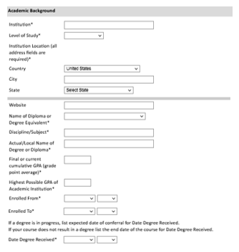

- To add additional entries for post-secondary educational institutions, click Add Institution and follow the bulleted instructions above.

Professional Experience
- List your current professional affiliation or employer and any relevant previous professional experience by clicking Add New Professional Experience under Professional Experience.
  - Choose the role which most closely corresponds to your current role and/or relevant previous professional work experience from the drop-down menu.
  - Enter position title (e.g. Director, Coordinator, etc.) or type of work (e.g. accounting).
  - Enter the name of your employer.
  - Enter the department name if applicable.
  - Select the start and end dates for the position you entered (Month-Year format). If you are currently employed in this role, leave the End Date fields blank.
  - Select the country where your current place of employment is located from the dropdown menu. Enter in the street address, city, state/region, and post code as applicable.
  - Click Save.

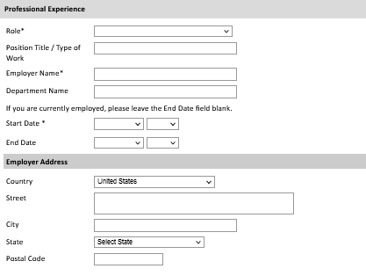

- If you have more than one current position and/or relevant previous professional experience, click Add Experience and follow the instructions above.

Awards and Recognitions
- Enter a list of the following items into the text boxes provided (all text boxes have a 250-word limit). If you do not have anything to add, leave text boxes blank:
  - Any scholarships and/or fellowships you currently or previously received (include the source or sponsor, amount, where held and duration).
  - Any academic honors and prizes that you have received in the text box (include any titles and/or dates).
  - Any books, articles, and/or theses published by you, particularly in your proposed field of study (include the title, place, and date of publication).
  - Any research you may have conducted or participated in.
  - Any professional societies, fraternities or other organizations in which you now hold membership or in which you have been active in the past.

Experience Abroad
- List any travel, study or residency you have had abroad (in any country other than your own) for more than one month from the last ten years. This can include time overseas for education, research, business, vacation, etc.
- Click Add New Experience Abroad.
- Select the country in which you spent your professional travel and/or residence abroad from the dropdown menu provided.
- Select the start and end dates (Month-Year format) of you travel/residency.
- Enter the purpose of your travel abroad.
- Click Save.

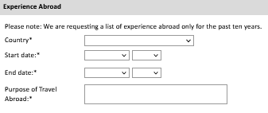

- If you have more than one trip abroad to enter, click Add New again, and follow the bulleted instructions until all entries have been saved.

- Select ‘Yes’ or ‘No’ to indicate if you have previously entered the United States on a J-1 or J-2 visa.
- If ‘Yes’, you are required to select the J category of sponsorship from the list and upload a copy of your previous DS-2019.

Previous Fulbright Grant
- Select ‘Yes’ or ‘No’ to indicate if you have previously been awarded a Fulbright grant.
- If ‘Yes’, you are required to list the grant(s):
    - Click Add Previous Fulbright Grant.
    - Select the Fulbright award type from the dropdown menu provided (e.g., Fulbright FLTA, Fulbright Foreign Student, etc.).
    - If you select “Other (please specify)”, enter in the name of the Fulbright grant that you received in the “Other, please specify” field.
    - Select the academic year that corresponds to the year in which you received the Fulbright grant.
    - Click Save.

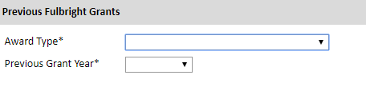

- Click Continue to save your responses and advance to the next section.

Academic Materials

This section collects copies of your unofficial transcripts with the diploma if applicable. Please consult the country-specific guidance provided in the application to determine what documents you should upload in this section.

If required, please upload scans of all available transcripts and diplomas from post-secondary institutions you have attended.

- Select the corresponding institution from the list.

- Review the institution information (which you provided on the previous page). If this information is incorrect, please return to the previous page to edit.

- Select Browse and locate the desired file on your computer. Click Open.
  - You may upload transcripts/diplomas as a multi-page documents or upload single page documents. PDF, JPEG, and TIFF image files are all accepted.

- Click Save. Repeat these steps for all applicable institutions.

- Click Continue to save your responses and advance to the next section.

Language Skills

This section collects information about your native language, English language skills, and any additional languages that are relevant to your project proposal.

- Select your native language from the dropdown menu provided.

English Language Proficiency
If your native language is not English, a section requesting your English language proficiency will appear.

- Rate your English language proficiency in Reading, Writing, and Speaking. Select Native, Advanced, Intermediate, Beginner or No Ability from the dropdown menus as appropriate.

Additional Language Skills
- Select the number of additional languages that you would like to include that may be of use for your project or study plans.

- Select the language you are reporting from the dropdown menu and rate your proficiency in Reading, Writing, and Speaking. Select Native, Advanced, Intermediate, Beginner or No Ability from the dropdown menus as appropriate.

- Click Continue to save your responses and advance to the next section.

Test Scores

This section collects information about standardized test scores that you have taken or will take in the future. Standardized tests include the TOEFL, GRE, GMAT and IELTS. Standardized test scores are often required for admission to U.S. institutions.

- Select Add Test.

- Select the test type from the drop-down menu.

- Select the test date from the drop-down menu (Month-Day-Year format).
  - If you have not yet taken the test, enter the date that you are registered for the test.

- Enter your test scores, if you have the results from the test.

- Click Save. Repeat these steps for all applicable standardized tests.

- Click Continue to save your responses and advance to the next section.

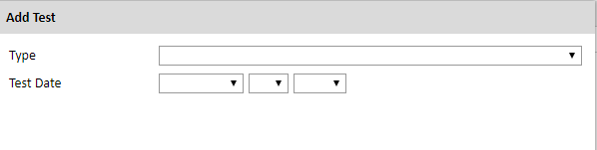

Score Reports

- If you enter test scores, you will be directed to the Score Reports section, where you will upload copies of your available score reports.
  - Click Browse.
  - Locate and select the file that you previously saved to your computer.
  - Click Open.
  - Click Upload to complete the file upload.

FLTA Information

This section collects information specific to the Fulbright Foreign Language Teaching Assistant (FLTA) Program. Please review country-specific guidance to determine whether you must provide additional information.

Language Skills
- Select the language you are applying to teach/assist in the U.S.

- Rate proficiency in the chosen language using the appropriate dropdown. Select Native, Advanced, Intermediate, Beginner or No Ability from the dropdown menus as appropriate.

- Indicate your Mother Tongue (Native) Language using the dropdown.

- Rate your overall level of English Proficiency using the appropriate dropdown. Select Native, Advanced, Intermediate, Beginner or No Ability from the dropdown menus as appropriate.

Preferences
- Using the drop-down menu, select which option you are willing to perform in your role as a language assistant on a U.S. university campus.

- Indicate if there is a particular region in the U.S. that you would most prefer. If you believe you are adaptable to all regions, please respond ‘I would accept any placement’.

- Indicate if there is a college or university type which you would most prefer. Select from the dropdown menu as appropriate. If you believe you are adaptable to all institution types, please respond ‘I would accept any placement’.

- Select if there are any college or university types which you would refuse an offered assistantship. Select from the dropdown menu as appropriate. If you believe you are adaptable to all institution types, please respond 'I would accept any placement’.

Teaching Experience
- Indicate, numerically, the total amount of language teaching experience in years and months that you currently have or previously held. The noted values for years and months should together total to the amount of time you have taught language.

- Please provide a brief overview of your prior language teaching experience:
    - Indicate level, class sizes, English and/or native language teaching experience for each position held.

Interests
- Input your academic and non-academic interests into the appropriate text boxes.

- Click Continue to save your responses and advance to the next section.

Plagiarism Agreement

- Carefully review the Plagiarism Agreement and indicate your acceptance of the terms by selecting ‘Yes’ or ‘No’. You will be ineligible for the program if any part of your Fulbright application is found to have been plagiarized.

- Click Continue to save your responses and advance to the next section.

Essays and Objectives

This section collects information about your objectives and motivations for applying for the FLTA program. In addition, you will be required to answer questions regarding your teaching methodologies and techniques and how you plan to share your culture in the U.S.

Objectives and Motivations
Please upload a well-structured essay that addresses your background and qualifications for the Fulbright FLTA Program, past experiences that have been formative in your personal development, reasons for applying to the program, and how being an FLTA will assist you in achieving your long-term career goals. Your response should be at minimum 700 words in length.

- Select Browse and locate the desired file on your computer. Click Open.
  - Uploaded objective statements are limited to a maximum of two pages. PDF, JPEG, and TIFF image files are all accepted. PDF is preferred.
  - Click Upload

Teaching Methodologies and Techniques
- Type a response that focuses on the teaching methodologies and techniques you would like to utilize to teach your language to U.S. students. This brief essay should focus on the language you will be teaching in the U.S. (not English). Mention any innovative approaches you have utilized as a teacher or encountered as a learner that you may employ. This response is expected to be 300-500 words in length.

Sharing your Culture
- Type a response choosing one of the three following scenarios: 1. A guest lecture at your host institution 2. An international festival 3. Volunteering at a local youth center; and explain what it means to be a cultural ambassador and how you would share your culture in the chosen scenario using your own unique perspective. This response is expected to be 300-500 words in length.

- Click Continue to save your responses and advance to the next section.

Additional Information

Country-Specific Materials/Supplemental Materials/Additional Documentation
  - Use this section to upload any required additional documentation per your country-specific guidance.

Other Grants and Awards
- Use the text box to indicate if there are any other scholarships, fellowships or employment that would supersede your participation in the FLTA program should it be offered.
  - If you select ‘Yes’, please provide further details regarding the noted scholarship, fellowship or employment.

Outreach Survey
- Complete the Outreach Survey.

- Click Continue to save your responses and advance to the next section.

Authorization of Release of Information

- Carefully review the Authorization of Release of Information statements.

- Type your signature in the provided text box to confirm your authorization of release of information.

Recommender Registration

Use this section to register your recommenders. Three references are requested. Refer to your country-specific instructions for any further details on the required number of recommenders.

Once you register your recommenders, they will receive an automatic email with instructions on completing the online recommendation form. You can track the status of recommendations, send reminders, and add/delete recommenders through this system before and after submission of your application. Letters of recommendation must be submitted directly by your recommenders either via the online application or to your Fulbright Program Office.

- Click Add Recommender.

- Complete all fields in the pop-up form.

- Click Send to Recommender to generate automatic email to recommender.

- Click Continue to save your responses and advance to the next section.

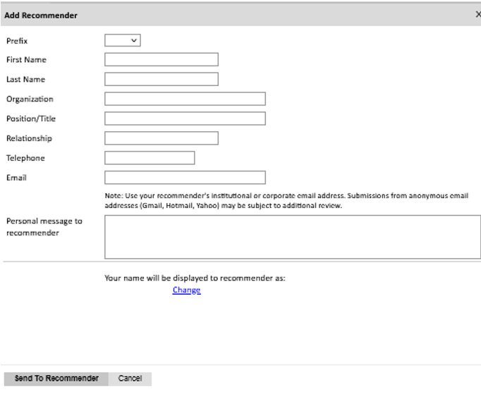

- Once sent, you will have the option to Edit Recommender information if they have not yet started progress on their response and Save, Send Reminders, and Exclude if you wish to remove the recommender and replace with another individual.

Signature

Review the information provided and certify that the information you provided in the application is true and complete by typing your full legal name in the Signature Box:

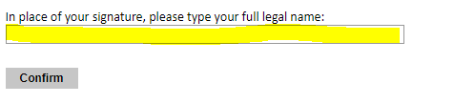

Click Confirm to continue to the next page.

Review

The application will review the responses entered and will display any incomplete questions and required attachments that are missing.
• If no errors appear, then your application is ready for submission.

• If any errors appear, correct or complete these sections and return to the Review section to determine if your application is ready for submission.
• Use the Click Here to Preview Application Proof to obtain a copy of your submitted application. Please note that the proof is for your records only. You must still submit your application online. Do not send this proof by mail as your application.

REVIEW ALL RESPONSES. CLICK SUBMIT.

