Iraqi Young Leaders Exchange Program (IYLEP)
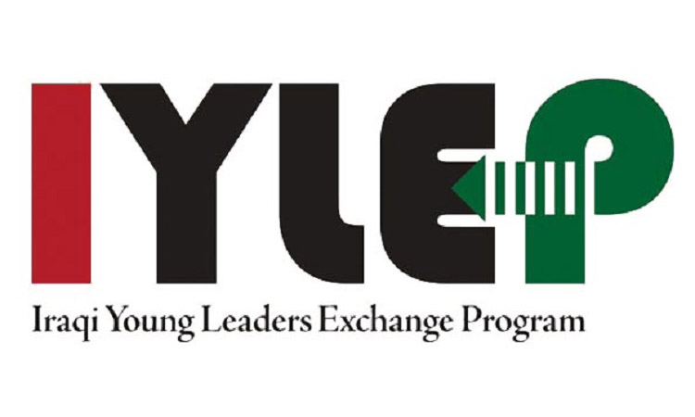
IYLEP is a four-week summer exchange program funded by the U.S. Embassy in Baghdad and the U.S. Department of State’s Bureau of Educational and Cultural Affairs. The program is currently administered by the U.S. NGO, World Learning. This flagship program provides Iraqi students the opportunity to develop leadership and community skills while learning about American culture as they travel across the United States. IYLEP high school and undergraduate programs have provided invaluable cross-cultural opportunities for approximately 4,500 Iraqi students since its creation in 2007. They return to Iraq as inspired young leaders who make a positive impact in their home communities. This year IYLEP will provide more than 200 Iraqi high school and undergraduate students with this unique educational exchange experience.
IYLEP for Undergraduate Students provides four weeks of fully-funded leadership training and classroom instruction to talented and dedicated students from Iraq. Participants, hosted at four universities throughout the United States, focus on many thematic “Institutes” Each Institute consists of classroom instruction, field trips, site visits, community service, leadership training, conflict resolution training, and cultural exchanges.

IYLEP for High School Students (in English) is a four-week youth leadership exchange based in the United States for Iraqi teenagers ages 15-17. Iraqi adult mentors also participate in this program as chaperones. The program aims to develop a cadre of young adults in Iraq and the United States who have a strong sense of civic responsibility, a commitment to community development, an awareness of current and global issues, strong interpersonal leadership skills, and a willingness to foster relationships among youth from different ethnic, religious, and national groups in Iraq.

IYLEP for High School Students (in Arabic) is a program modeled on IYLEP (in English), that brings together high school students aged 15-17 and their adult mentors for a similar dynamic four-week program but provides Arabic translation. Students develop skills in leadership, civic education and responsibility, diversity awareness and tolerance, and civil engagement, as well as have opportunities for structured English-language learning. This program caters to students who meet the same eligibility criteria for IYLEP except for English language proficiency.

Iraqi high school students who possess English proficiency should apply for the IYLEP in English program.

Interested applicants should check eligibility requirements and apply at www.iylep.org/apply

There is no cost to apply to IYLEP. The U.S. Department of State will fully fund students’ academic study, travel, health insurance, housing, and provide a modest living allowance while in the United States.

For questions about the program, please email iylep@worldlearning.org.

