The U.S. Consulate in Ciudad Juarez Chihuahua, Mexico is requesting quotes for **Pollinating Garden and Landscpaing Redesign** as per product specifications below. ***Please send all quotes no later than April 15th, 2023 at 4:00 pm (mountain time) to this email address [CalvilloMA@state.gov](mailto:CalvilloMA@state.gov). No quotes will be considered after this date and time. Mexican vendors must quote in pesos unless they have a U.S. Dollar bank account in Mexico. DUNS number on quote is mandatory. NDAA 889 Compliance Policy document is mandatory for all vendors, please include the document with your quote.

***An extension has been approved until June 16th, 2023, and a Site Visit is scheduled for June 7th, 2023 at 10:00 am. For site visit info please contact Rene Medina at [MedinaR@state.gov](mailto:MedinaR@state.gov)

TASK ORDER - STATEMENT OF WORK

FOR

LANDSCAPE ARCHITECTURE SERVICES

Design and

Construction Documentation Services

U.S. Consulate Ciudad Juarez

Pollinating Garden and Landscaping Redesign

Project:

**Ciudad Juarez, Mexico**

**February, 2023**

UNCLASSIFIED

Table of Contents

Project: 0

PART 1. GENERAL 3

1.1 General Requirements: 3

1.1.1 Introduction 3

1.1.2 Project requirements 3

1.2 Design Objectives: 3

1.3 Design Policy and Criteria: 4

1.4 Site Description: 5

1.5 Location and Points of Contacts: 5

1.6 Project Completion Date: 5

2.1 Site Inspection and Design Phase: 6

2.1.1 Site survey and analysis: 6

2.1.2 Site Visit 6

2.1.3 As-Built Documents (available from OBO ) 6

2.2 Task 1, Preliminary Design Submittal (90%) ...........................................................................................6

2.3 Task 2, Final Design Submittal (100%): 6

2.4 Professional Consultation: 6

2.5 Design Submittals: 7

2.5.1 Task 1, 7

2.5.2 Task 2, 7

2.7 Specifications: 8

2.8 Drawings: 8

2.9 Construction Cost Estimate: 9

2.10 Quality Control: 9

2.11 Schedule: 9

2.12 Correspondence & Packages: 9

PART 3 DESIGN REQUIREMENTS 10

3.1 General 10

3.2 Site Improvements: 10

3.2.1 West Representational Area: 10

3.2.2 Applicant Waiting Area: 10

3.2.3 East Residential Area: 11

3.2.4 Outdoor Break Area: 11

3.2.5 Perimeter Areas: .........................................................................................................................11

3.2.6 Consulate General Residence Areas: ........................................................................................11

3.2.7 Site Drainage: ........................................................................................................................... 11

3.2.8 Passive Shading: ....................................................................................................................... 11

3.2.9 Irrigation 11

3.2.10 Maintenance Requirements: ..................................................................................................12

4.1 Construction Procedures: 12

4.1.1. Bid procedures: 12

5.1 Drawings: ........................................................................................................................................13

A Consulate Compound

A.1 West Representational Area: ..................................................................................................13

A.2 Applicant Waiting Area: ..........................................................................................................16

A.3 East Recreational Area: ..........................................................................................................18

A.4 Outdoor Lunch Sitting Area ...................................................................................................19

A.5 Perimeter Areas: .....................................................................................................................22

B Consulate General Residence

B.1 Front Area: .............................................................................................................................23

B.2 Pedestrian: .............................................................................................................................25

B.3 Side Area: ...............................................................................................................................26

B.4 Back Areas: ..............................................................................................................................28

B.5 Generator Area: ......................................................................................................................29

# PART 1. GENERAL

## 1.1 General Requirements:

### 1.1.1 Introduction

The United States Government (USG), Department of State (DOS), Bureau of Overseas Buildings Operations (OBO) requires architectural and engineering services to upgrade sustainability by improving the landscaping at the U.S. Consulate in Ciudad Juarez , Mexico as described in this Statement of Work (SOW). The goal is to drastically reduce the daily water usage from the irrigation system while improving the appearance and functional use of the Consulate Compound. In additional, the Consulate would like to maximize the number of pollinating plants in the landscape. The Consulate does not wish to consider using artificial turf or any other artificial grass of any kind. However, using pavement or other hardscape are viable alternatives.

### 1.1.2 Project requirements

The Landscape Architect shall perform all professional landscape architectural services required for the amendment of the representational and recreational lawns. The services shall include but are not limited to the design and construction detailing of hardscape and softscape landscape elements, soil amendment, irrigation and drainage analysis for fine grading work to promote positive water runoff away from any present built structures. The work should be conducted in consultation with Post and OBO’s landscape architect.

The services shall be performed in two tasks:

1. TASK 1, Preliminary Design Submittal (90%), a set of specifications and construction costs estimate.
2. TASK 2, Design Completion and Bidding/Corrected Final Design Submittal (100%) which shall require final construction documents for the solicitation of bids.

Any documents provided by Overseas Building Operations [OBO] and the Consulate to the consultant are intended as guidance and not to be interpreted as the only solution. All documentation/drawings submitted must be in English.

## 1.2 Design Objectives:

The design work should satisfy the following major objectives:

1. The landscape architect shall design a landscape solution that promotes water conservation, passive shading and universal accessibility.
2. The landscape architect shall develop a tree preservation plan as part of the construction documentation set to support the identified scope of work and limit of disturbance.
3. The landscape architect shall provide an irrigation system analysis of the current system. The contract should then provide irrigation design drawings for any removal of irrigation components and any additions when irrigation is necessary to the new landscaping design. The drawings shall include an irrigation schedule all of the plants. Additionally provide a list of materials needed to modify the current irrigation system to the proposed design.

### 1.3 Design Policy and Criteria:

All architectural and engineering design work shall conform to the more stringent requirements of the following attached codes and standards:

* Americans with Disability Act Accessibility Guidelines (ADAAG)
* 2021 OBO Design Standards for Representational Residences
* 2020 OBO CAD Standards

Applicable Expertise:

The landscape architect and sub-consultants shall meet the necessary professional licensing requirements or equivalent to perform the design and engineering services for this project. The licensing requirements apply to the fields of landscape architecture and civil engineering.

Applicable Building Permitting Expertise:

The landscape architect shall identify the permitting authorities and permit approval process as described in this SOW.

### 1.4 Site Description:

A. The Consulate Government Owned property is located at:

Paseo De La Victoria #3650 Partido Senecu Ciudad Juarez, Mexico

The landscape areas to be considered for redesign to include, but not limited to the campus areas below:

|  |  |
| --- | --- |
| 1. West Representation Area | 567 Square Meters |
| 2. Applicant Waiting Area | 448 Square Meters |
| 3. East Recreational Area | 342 Square Meters |
| 4. Outdoor Lunch Area | 104 Square Meters |
| 5. Perimeter Areas | 1530 Square Meters |

B. The Consulate General Officer Residence is located at:

The landscape areas to be considered for redesign include, but not limited to, the residential areas below:

|  |  |
| --- | --- |
| 1. Front Area | 350 Square Meters |
| 2. Pedestrian Entrance | 60 Square Meters |
| 3. Side Area | 40 Square Meters |
| 4. Back Area | 120 Square Meters |
| 5. Generator Area | 28 Square Meters |

### 1.5 Location and Points of Contacts:

Robert Crumrine, Facility Manager

Contracting Officer (CO):

Nathan Johnson, General Service Officer

### 1.6 Project Completion Date:

Final biddable and constructible construction documents shall be received at the Embassy and CO no later than ***DATE TBD****.*

PART 2. SCOPE OF SERVICES

## 2.1 Site Inspection and Design Phase:

### 2.1.1 Site survey and analysis:

The landscape architect and consultants shall conduct the necessary site investigations to verify the project requirements, measurements, and locations of all existing surface and sub-surface utilities and structures that are pertinent to the identified scope of work.

### 2.1.2 Site Visit

The landscape architect and consultants shall visit the site -to verify that the existing conditions are validating the project scope. The presence of existing electrical, mechanical, structural, plumbing, and other service elements should also be field verified.  Any findings that are at variance with the provided as-built documentation should be reported.

### 2.1.3 As-Built Documents (available from OBO)

The landscape architect and consultants shall gather as-built construction documents available at site as necessary for additional information that may be pertinent and useful in the development of their submissions.

2.2 Task 1, Preliminary Design Submittal (90%):

The landscape architect and consultants shall develop a preliminary design package that clearly conveys the existing and proposed site conditions. The package shall coherently illustrate a new functional and efficient layout for the lawns using all applicable standards. The package should also include a demolition plan and tree preservation plans that describes utilities, site walls and site features to be removed/relocated from site, including landscape and sub-surface materials. Any required additional work, or changes to the present scope shall be provided via written recommendations and submitted to OBO and the Embassy for review and approval.

## 2.3 Task 2, Final Design Submittal (100%):

Upon OBO and the Embassy’s approval of the Preliminary Design Submittal (90%) the landscape architect and consultants shall incorporate all the design and engineering review comments and proceed with the development of their final design submittal.

## 2.4 Professional Consultation:

The landscape architect and consultants shall participate in meetings and be available for consultations as required by the Contracting Officer or his duly authorized representative during the project execution. This requirement does not include short-term telephone requests for interpretation of plans and specifications which can be furnished at once without a detailed study, nor to corrections of omissions or errors or conflicts in plans and specifications which are considered the landscape architect responsibilities that shall be corrected as part of this contract at the landscape architect expense.

## 2.5 Design Submittals:

All submittals and following materials are the Embassy’s property:

2.5.1 Task 1, Preliminary Design Submittal (90%):

AutoCAD Files, PDF Drawings, and (2) full size printed copies (1) in

English according to 2020 OBO CAD Standards.

1. Site plans (demolition plan, tree preservation plan, layout and grading plan, planting plan), sections, and details, as required to per SOW.
2. Basis of Design narrative
3. Preliminary construction costs estimate.
4. Preliminary Design and Technical Specifications.
5. Electronic CAD work and specifications on CD-Disk. Label disk “TASK 1, Preliminary Design Submittal (90%)”

2.5.2 Task 2, Final Design Submittal (100%):

AutoCAD Files, PDF Drawings, and (2) full size signed and sealed printed copies (1) in English.

1. Revised site plans, sections, and details, per 90% Review Package comments.
2. All drawings to be signed and sealed by registered landscape architect and/or professional engineer.
3. Completed Specifications on 8 1/2"x11", plain bond, white paper, letter quality prints and burn onto a CD-Disk in Microsoft Word original specifications.
4. Completed detailed cost estimate plus CD-Disk in Microsoft Excel original cost

estimate.

1. Electronic CAD work and specifications on CD-Disk. Label disk “TASK 2, Preliminary Final Design Submittal (100%)”
2. Final Finishes Binder with proposed landscape architectural finishes samples and cut sheets.

Included as part of the Final submittal are consultation services during the construction

solicitation period. This work includes, but is not necessarily limited to:

1. Providing clarifications and responses to questions about the construction documents

prepared by the Contractor.

1. Preparation of drawings or documents that may become necessary for inclusion in

amendments to the construction contract solicitation because of such clarifications or questions.

1. Attendances at the construction pre-proposal conference to be held at the Post.

## 2.7 Specifications:

The landscape architect shall prepare project specifications in the "CSI" format utilizing OBO Standard Specifications. Alternate U.S. based specifications may be used upon approval of the COR and includes MasterSpec developed by ARCOM (Architectural Computer Services, Inc.) and UFGS (Unified Facilities Guide Specifications); this is the Guide Specifications for use in specifying construction for various U.S. government agencies. Specifications shall be prepared so that the Embassy can invite bids and award a single federal construction contract per Delivery Order in accordance with Federal Acquisition Regulations (FAR) and shall in be in English. Specifications shall be on 8 1/2" by 11", plain bond, and white paper with letter quality printing. Final submission of specification using Microsoft Word shall include in digital media CD ROM Format using proper external label with a certification that the delivery media is free of known computer viruses including the name(s) and release date(s) of the virus scanning software

used to check the media.

Submissions shall identify minimum height and caliper (DBH) of tree species in Planting Schedule/Inventory to inform nursery procurement.

## 2.8 Drawings:

CAD drawings will conform to the National CAD Standards published by the

National Institute of Building Sciences. Drawings shall be in AutoCAD platform (ACAD 2012) without conversion; layering, lettering, line weight, symbols, schedules shall be in conformance with current National CAD Standards (NIBS). All CAD drawings shall be supplied in DWG format and readable by the DOS supported CAD desktop software (Autodesk AutoCAD). Being ‘readable’ means the ability to open a file without any errors (such as proxy, font substitution, xref resolution, etc.) and with

objects, layers, and other file properties remaining intact. Submission of digital files (.dwgs) shall include in digital media CD ROM Format using proper external label with a certification that the delivery media is free of known computer viruses including the name(s) and release date(s) of the virus scanning software used to check the media.

Drawings shall be developed using the metric system of measurement (SI Units). SI drawings shall use only millimeters (mm) to avoid fractions and to eliminate the repetitious suffix. Dual dimensions shall not be used. Drawings shall be in English.

Graphic Scales:

Site Plan – 1:500, minimum

Plans – 1:100, minimum

Details – 1:5 thru 1:20

## 2.9 Construction Cost Estimate:

The landscape architect shall prepare an electronic cost estimate, using Microsoft Excel, for each identified area from section 1.4 to be submitted for review to reflect an estimate of total construction costs for the project. The estimate shall provide sufficient detail using descriptive building component line items with corresponding units for quantities, materials and labor. Total costs shall include contractor overhead, profit and taxes.

## 2.10 Quality Control:

Prior to Task 2, Final Design Submittal (100%) submission, the landscape architect shall perform a quality control review of all drawings and specifications. The review shall check for technical accuracy, coordination of the work within discipline, interdisciplinary coordination of the work, and coordination between drawings and specifications. When poor landscape architect performance results in the need of re-submissions of design documents, the landscape architect may be required to send representatives to the Embassy and /of project site to discuss the problems at no additional cost to the Embassy.

## 2.11 Schedule:

1. General:

Consultant to submit insurance and documentation within **5** calendar days.

1. Task 1, Preliminary Design Submittal (90%):

Consultant to submit preliminary design package **30** calendar days after issuance of Notice To Proceed (NTP).

1. OBO Review/Comments

OBO to provide comments within **7** calendar days.

1. Task 2, Final Design Submittal (100%):

Consultant to submit their preliminary design package **10** calendar days.

## 2.12 Correspondence & Packages:

Correspondence and Packages (or privately delivered mail) shall be addressed to Embassy to

the following address with a formal prior coordination with the Contracting Officer

Representative (COR):

# PART 3 DESIGN REQUIREMENTS

## 3.1 General

The US Embassy will provide notional design directions that shall be used as the basis for developing the design and specifications. The directions will launch the design intent but will not describe the entire scope of work required for the full performance and completion of the project. The designer can recommend and design landscaping modifications for more areas within the Consulate and Consulate General Residence then identified within this Statement of Work.

The following describes some basic recommendations and spatial fit-out directions to accommodate the new functions, those include but are not limited to:

## 3.2 Site Improvements:

The landscape design solution shall propose landscaping areas for improvement in a way that seamlessly integrates with the site’s existing conditions and grading. The landscape character should be representational and complement the building architecture, existing settings, and intended function for campus users. The Consulate wishes to optimize the planting of pollinators and drought-tolerant plants that thrive in the local climate. Another goal is to ensure that the plants are easy to maintain by the local staff and not hazardous to the community. Along the perimeter walls, the design shall not block any of the security cameras shall not be climbable.

### 3.2.1 West Representational Area:

This area serves as an area to represent the United States to foreign dignitaries and from the United States as well. This area is also used as a break area and a comfortable place to have small meetings. The Consulate would consider installing pavers, this should be indicated with pervious and paving solution with SRI values that are cooling the campus microclimate in much of the lawn area with benches having the plants and floral activities in the foreground and integrated within.

### 3.2.2 Applicant Waiting Area:

This area serves as an extended uncovered waiting area that is not utilized as design due to the fact that being uncovered is very hot. The Consulate hopes that a design would provide shade with pollinating plants to fill in the open spaces as maximum extent. However, the applicants bring children that the type of plants should be to avoid a wandering child being becoming injured.

3.2.3 East Residential Area

This area is at the farthest end of Consulate operations. However, it's location is ideal for employees that wish to take a break from stress. The goal is to provide sitting such as benches to be filled with trees or tall plants to provide shade with pollinating plants to fille the spaces. The area could be left unpaved with curved paths to cross similar to a small city park.

3.2.4 Outdoor Break Area

This area serves as an eating area outside that has metal retractable coving that is opened and closed as needed to provide shade to the staff during lunch break. Outside of the lunch periods, the cover is opened to provide light to the plant life.

3.2.5 Perimeter Areas

These areas are mostly ditches to allow storm water to collect and drain. That are filled with small rocks and bare in appearance. Short flowering plants would be ideal. These areas need to maintain a narrow path along the perimeter wall for security purposes either by patrolling guards and not to block the perimeter view of the security cameras.

3.2.6 Consulate General Residence Areas.

The Consulate General Residence is home for the family. However, this area serves as an area to represent the United States to foreign dignitaries and from the United States as well.

3.2.7 Site Drainage:

The landscape design shall promote positive surface drainage throughout, to keep water away from the building structure and foundation. All surface drain covers that are located at the public areas to be ADA compliant.

### 3.2.8 Passive Shading:

The landscape design could integrate trees or other plants for passive shading device as needed.

### 3.2.9 Irrigation

The landscape design shall be coordinated with the existing irrigation layout plan, and developed in consultation with the Facility Management Engineers, to mitigate construction overlaps and/or conflicts. It is expected that the irrigation plan will need to be modified and the design should include the modifications to reduce water and promote healthy plants that would still need irrigation as needed. The design should list the Bill of Materials for the modification. Also indicated the demolition, or components that will be removed, and the additions with exact location that coordinate with the plants that are being irrigated.

3.2.7 Maintenance Requirements

The maintenance requirements and schedule for pruning, irrigation, fertilization, and any other requirements needed for the plants to thrive each year shall be including in the design.

PART 4 EXECUTION

## 4.1 Construction Procedures:

### 4.1.1. Bid procedures:

The Contracting Officer at the Embassy, will invite for bids for construction, and will

award and administer contract.

**A. Consulate Compound**

**1. West Representational Area.**Approximately 567 Square Meters

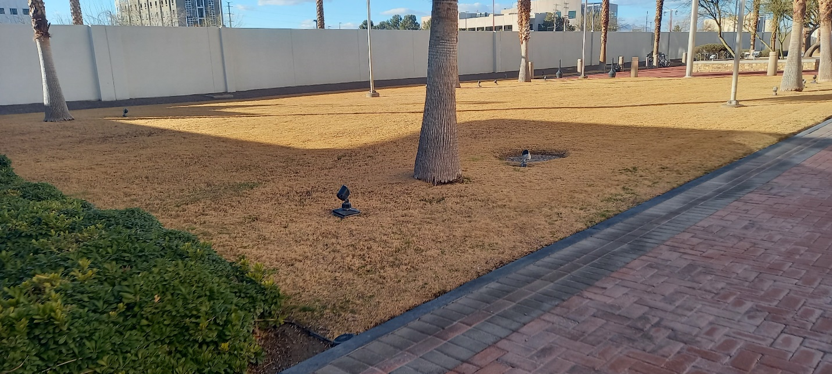

**2. Applicant Waiting Area.**   
Approximately 448 square meters

**3. East Recreational Area**.   
Approximately 342 Square Meters.

**4. Outdoor Lunch Sitting Area.**   
Approximately 104 square meters.

**5. Perimeter Areas.**   
Approximately 1530 Square meters.

**B. Consulate General Residence**

**1. Front Area**

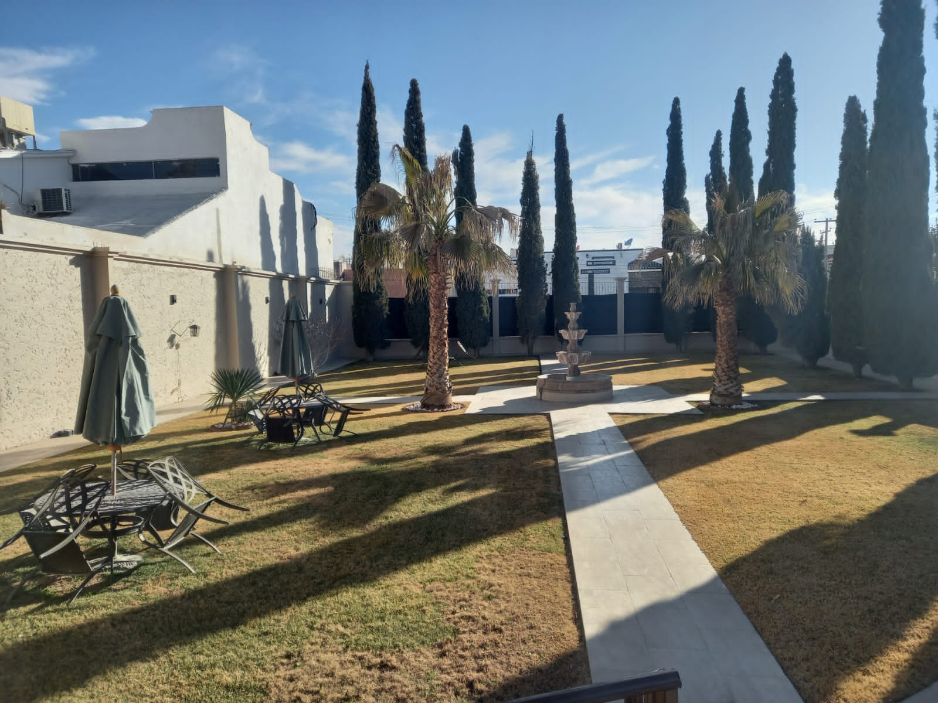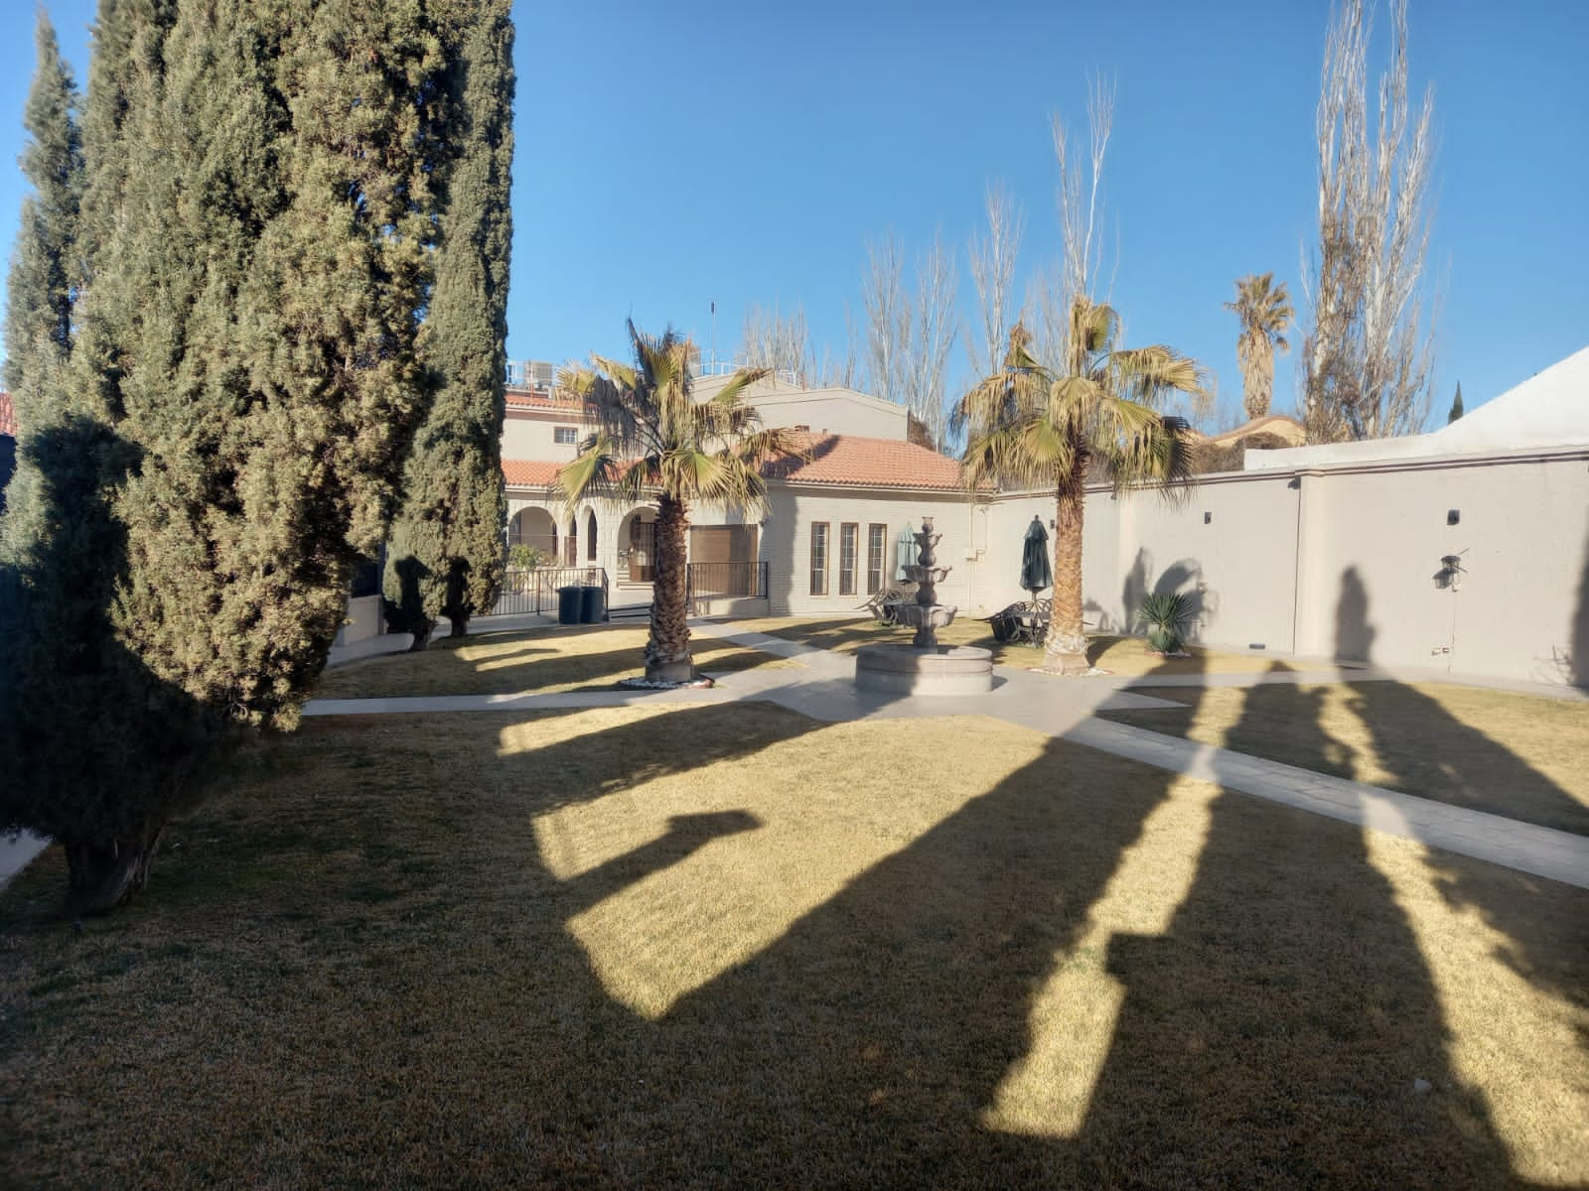

**2. Pedestrian Entrance**

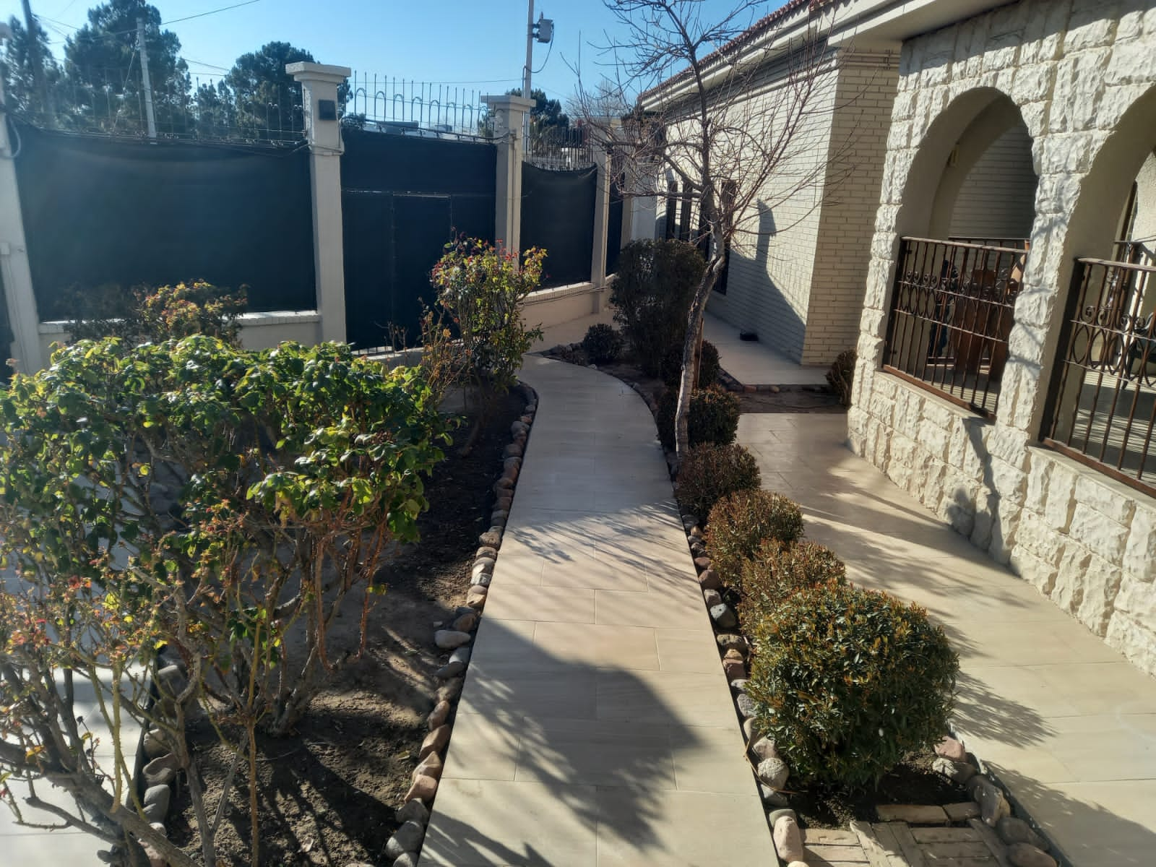

**3. Side Area**

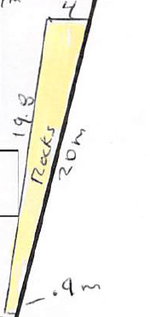

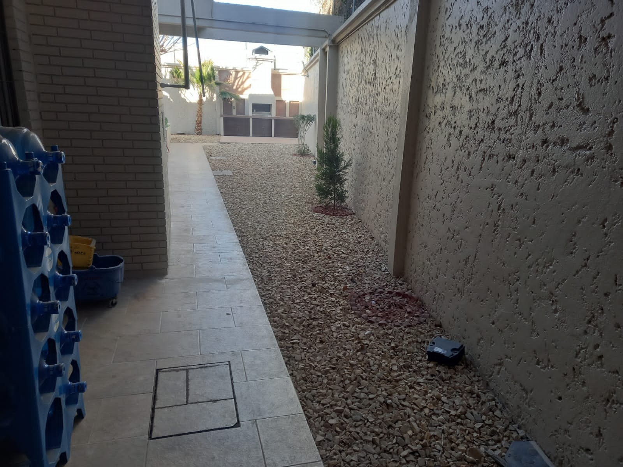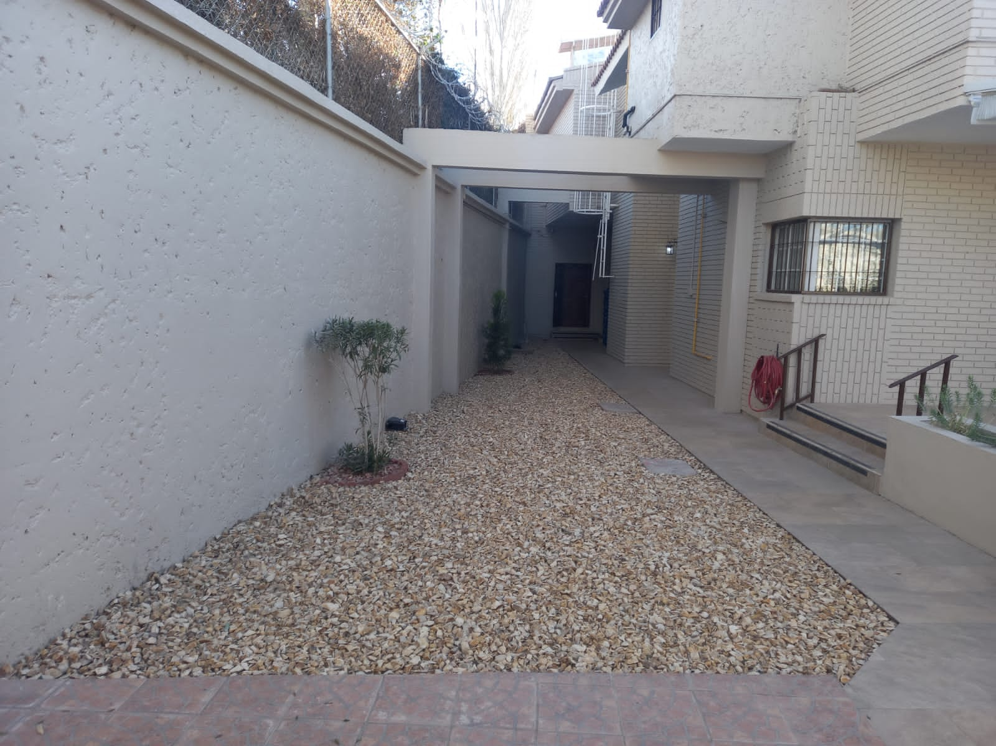

**4. Back Areas**

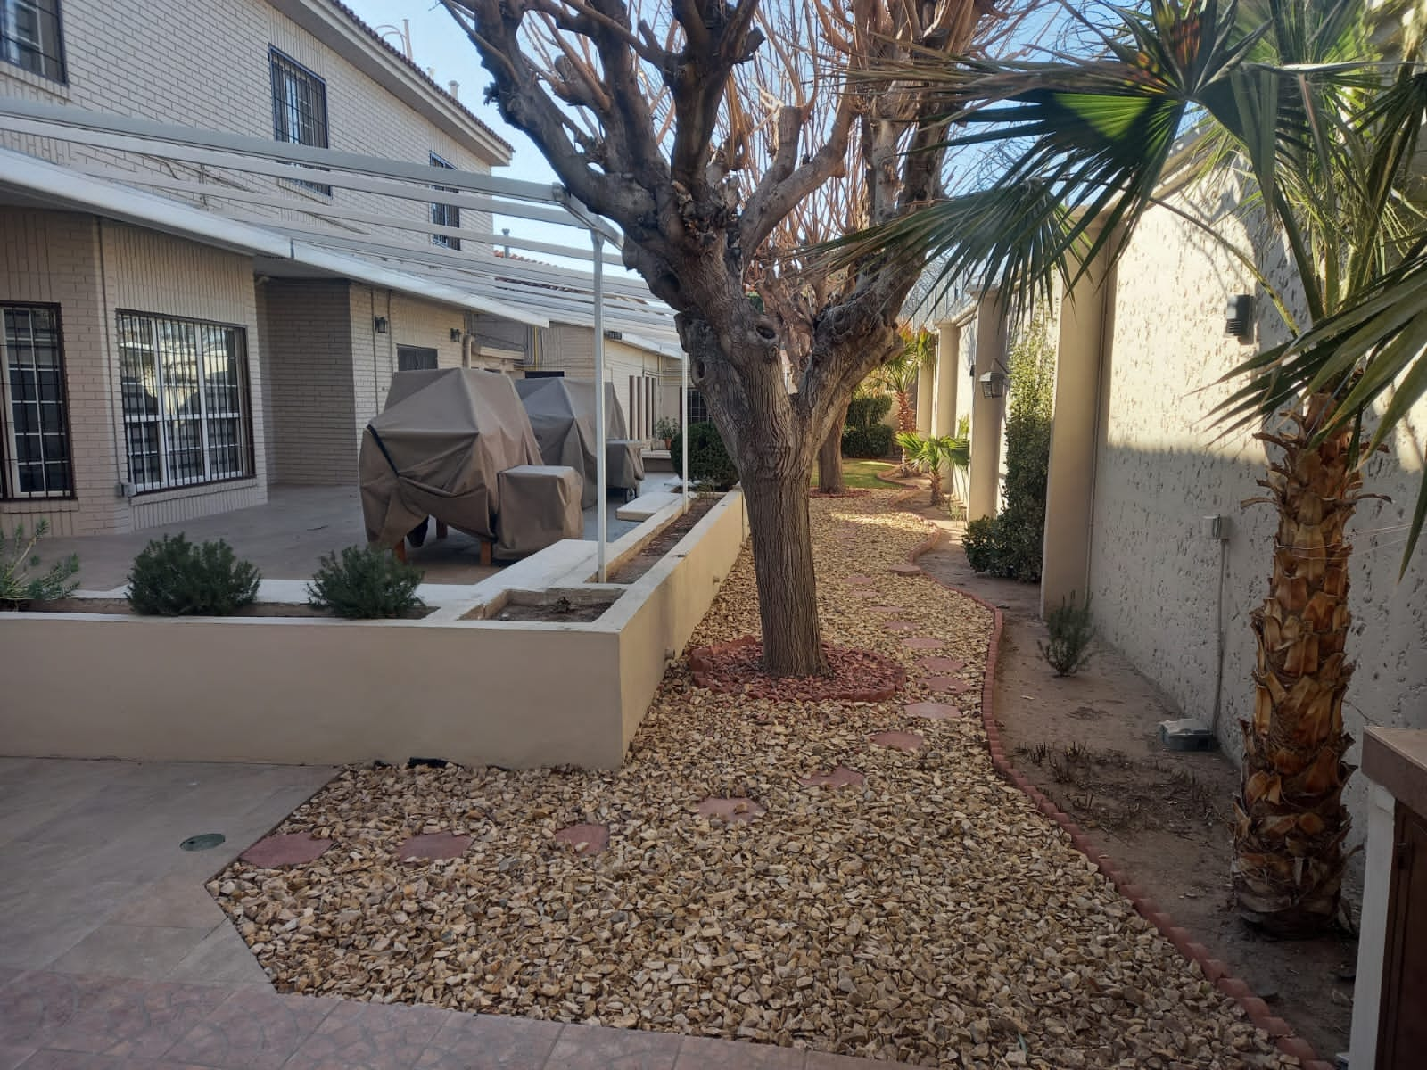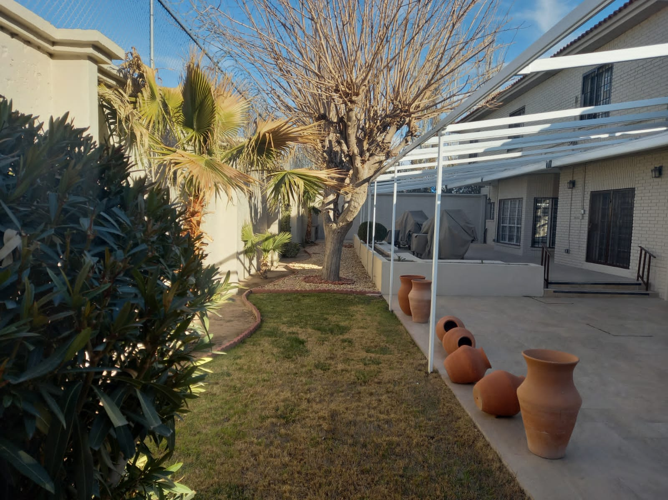

**5. Generator Area**

