**RETROFIT TOYOTA HIACE CARGO VAN FOR WELDERS – WITH DOUBLE DROP-DOWN LADDER ON TOP AND A CABINET IN THE INTERIOR**

[LADDER RACKS FOR FORD VANS – Volition Components](https://www.volitioncomponents.com/products/ladder-racks-for-ford-vans?variant=41666282061984) (HIGH ROOF, DOUBLE DROP-DOWN)

<https://cdn.shopify.com/s/files/1/0573/8361/6672/products/hqdefault_17708f6b-e8ec-4d4e-b1c7-97f0e2a5dd02_110x110@2x.jpg?v=1643228655>

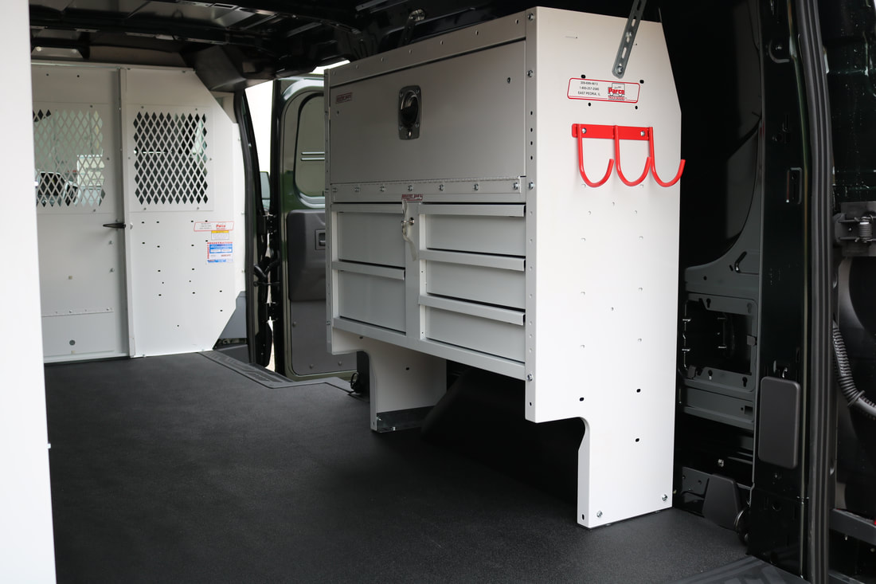

**CABINET**

**DESCRIPTION**

The cabinet should be retrofitted inside the van to the left (the side of the driver) while the two high roof double drop-down ladders should be outside on top of the van as shown in the links provided.