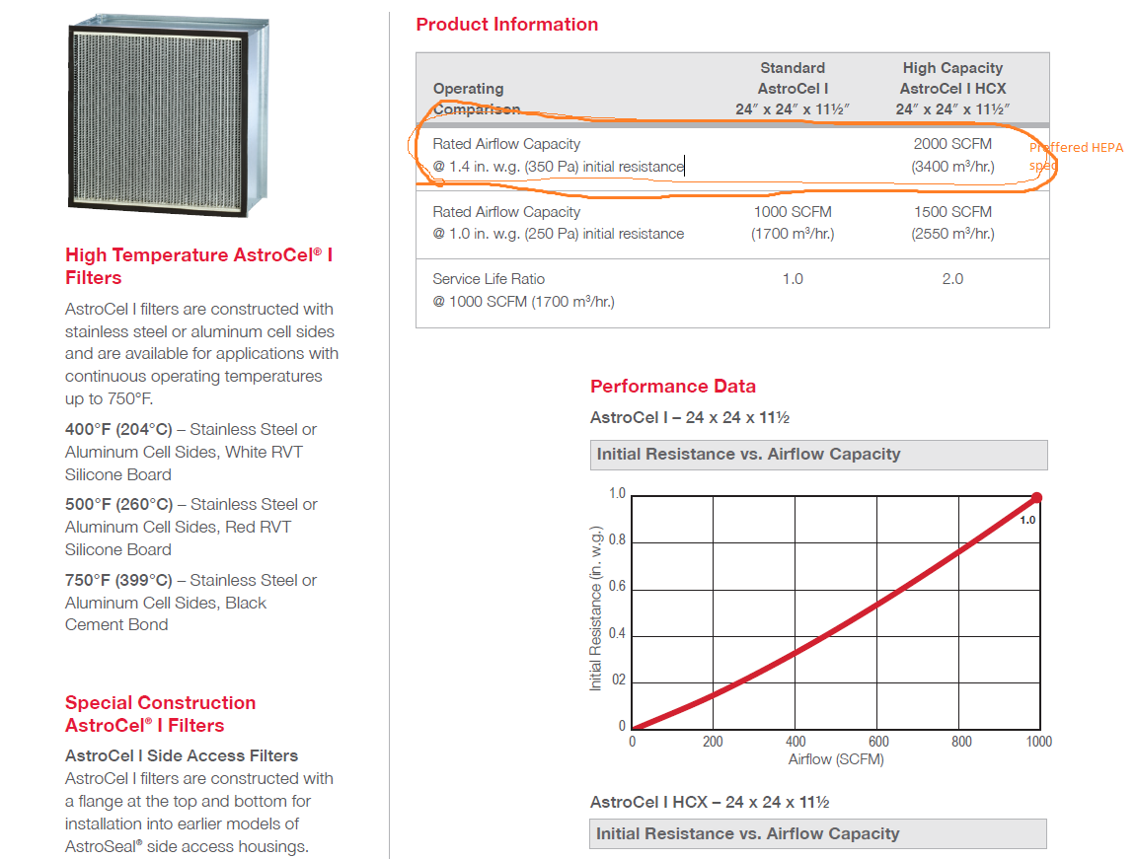

See highlight for the HEPA Filter spec.

