U.S. DEPARTMENT OF STATE  NOFO APPLICATION PACKAGE CHECKLIST - OVERSEAS |  | 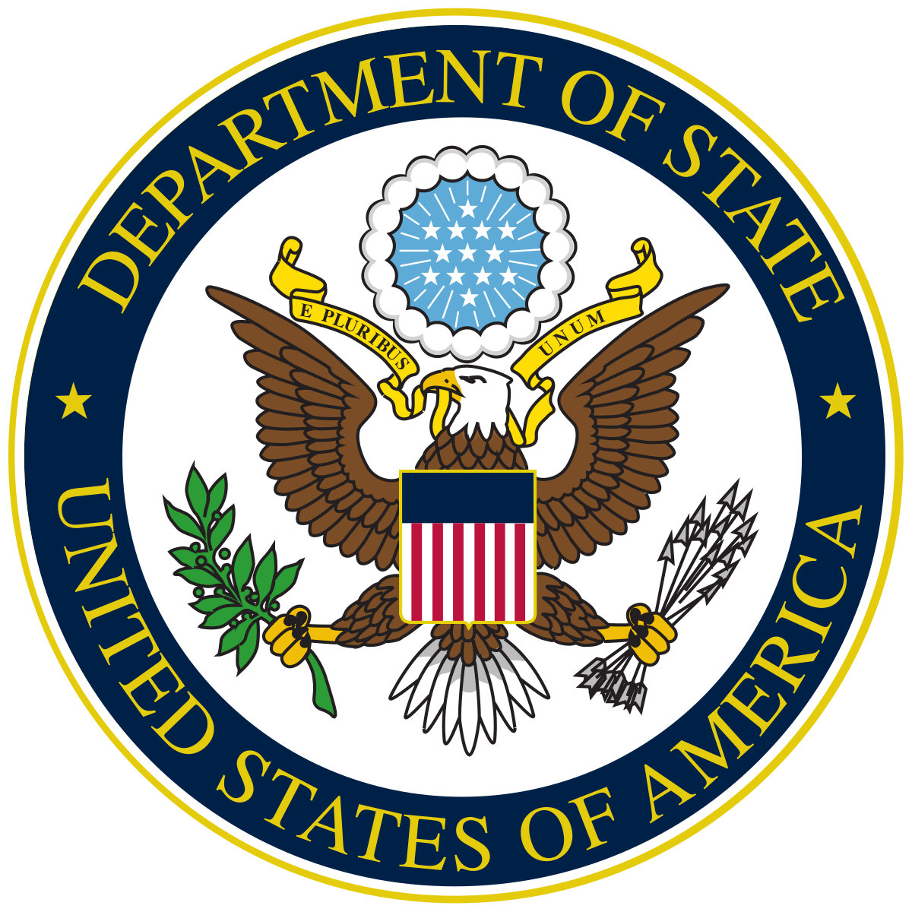
NOFO APPLICATION PACKAGE CHECKLIST - OVERSEAS
☐ | SF-424
☐ | SF-424A
☐ | SF-424B
☐ | SF-LLL (if applicable)
☐ | Cover Page/Executive Summary
☐ | Table of Contents
☐ | Proposal Narrative
☐ | Scope of Work (required template provided as attachment)
☐ | Performance Monitoring & Evaluation Narrative and Plan (sample template provided as attachment)
☐ | Timeline
☐ | Gender and Inclusion Analysis (only if applicable)
☐ | Detailed Budget (sample template provided as attachment)
☐ | Budget Narrative (sample template provided as attachment)
☐ | If the budget includes subawards, please include a separate Budget Narrative for each organization.
☐ | NICRA Letter
☐ | Single Audit or recent independent financial audit
☐ | Key Personnel Summary
☐ | CV or Resume of Key Personnel
☐ | Security Plan (only if applicable)
☐ | Contingency Plan (only if applicable)
☐ | COVID Contingency Plan
☐ | Burma Due Diligence Assessment (only if applicable)
☐ | Letters of support from program partners
☐ | Official permission letters, if required for project activities
☐ | Letter of Disclosure for proposed consultants/personnel of potential conflicts of interest (if applicable)
☐ | Letter(s) of Institutional Support to indicate that organization’s leadership supports application
☐ | EIN (organizations based in the U.S.) or NATO CAGE (organizations based outside of the U.S.)
☐ | SAM.gov Entity Registration

