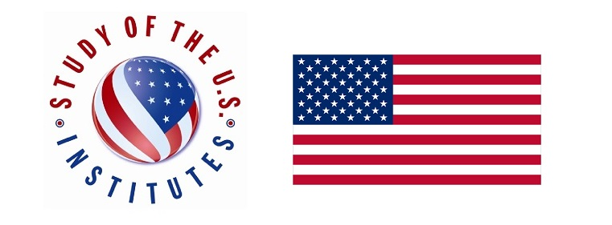
Title of the Institute: Female Leadership

Full name as it appears in your passport
Surname (Last) Name:
Given Names:
Sex: | RFemale
Date of Birth | Please write down DAY, MONTH YEAR
Birth City (village):
Birth Country:
Citizenship:
Residency:
Medical, Physical, Dietary, or other Personal Considerations:
Candidate’s Personal Statement:
What is your primary motivation for participating in the SUSI Young Women Leaders program? The essay should be no more than 200 words.
Tell us about yourself and your goals, including the following: What about your background and/or interests makes you competitive for the SUSI exchange program? How will the program affect you personally or professionally? Please structure your essay in paragraphs and limit your response to 500 words, or approximately a page, single spaced.

Describe any volunteer, mentoring, or community activities in which you have participated, with specific focus on how these activities have affected women and girls. Describe in no more than 150 words.
Is there anything else you think would be useful for us to consider when we evaluate your application? Please explain. Describe in no more than 150 words (optional)
Candidate Contact Information:
Street Address: |  | City: | State/Province:
Postal Code: |  | Country: | Phone Number:
Email Address:

Institution Name:

Institution Country:

Year in School. Please choose the relevant one.
­completed first year
­completed second year
­completed third year
Graduation Date Please write down DAY, MONTH YEAR
Major:
University:
Co
Work history:
Active Professional Memberships (associations, clubs, etc.). Please limit to three most relevant
Position:
Title:
Organization:
From Please write down DAY, MONTH YEAR
Until Please write down DAY, MONTH YEAR
Position:
Title:
Organization:
From Please write down DAY, MONTH YEAR
Until Please write down DAY, MONTH YEAR
Position:
Title:
Organization:
From Please write down DAY, MONTH YEAR
Until Please write down DAY, MONTH YEAR
Have you traveled to the United States before? YES |  |  |  | NO
If yes, please provide dates and purpose of visit(s)
Example: July 4-14, 2019 Tourism to Washington, D.C.

If no, please describe your travel experience outside of your home country.
Family Residing in the United States. Please include city and state (Example: Jane Doe – Denver, CO).
Evidence of English Fluency. Please indicate the level of English language fluency. Provide English language certificates if possible
- Intermediate
- Upper-Intermediate
- Advanced
Current Extra-Curricular/Co-Curricular Activities in Leadership:
Activity:
Position/Title:
Started: Please write down DAY, MONTH YEAR
Completed: Please write down DAY, MONTH YEAR
Description of Duties:

