Fulbright Foreign student Program
Instructions for Completing the
2024-2025 Fulbright Foreign Student Program Application
Placement Type: IIE-Placed

Application: https://apply.iie.org/ffsp2024
Read all instructions carefully before completing the application.
Applicants may only apply for one award per application cycle.

Contents
General Information 3
Creating Your Online Account 4
Managing Your Application 6
Preliminary Questions 7
Country Information 8
Personal Information 9
Contact Information 10
Academic & Professional Information 11
Curriculum Vitae/Resume 11
Academic Background 11
Professional Experience 12
Awards and Recognitions 13
Experience Abroad 14
Academic Materials 16
Language Skills 17
English Language Proficiency 17
Additional Language Skills 17
Test Scores 18
Score Reports 18
Plagiarism Agreement 19
Study Plan 19
Intended Grant Period 19
Study/Research Objective 19
Personal Statement 20
Writing Sample 20
Letter of Invitation 20
University Preferences 20
Authorization of Release of Information 21
Grant and Travel Plans 22
Financial Information 22
Family Funds 22
Expected Additional Funding 22
Passport/Travel Document and Dependents 23
Additional Information 23
Recommendations 24
Signature 26
Review 26

General Information

The application is supported by all modern browsers. We highly recommend that you use a current version of Google Chrome, which supports Windows, Mac, and Linux platforms.

Prior to starting an application, please complete the following steps:
Step 1: Learn requirements for submitting an application
Before you begin an application, contact the Fulbright Program Office in the country from which you are applying. Deadline dates and application requirements for a Fulbright grant will vary from country to country. You must make sure you are eligible to apply. Additional information and a list of participating countries can be found here: https://foreign.fulbrightonline.org/.

Step 2: Record username and password in a safe place
Your email address is your username. When you create an account for this online application, record your password in a secure place. You can log in and out of the application as frequently as you like using your username and password. If necessary, you can reset your password by clicking the “Forgot Your Password” link on the log-in page.

Step 3: Complete the application
You do not need to complete this application at one time. You can re-enter at any time to edit your application. However, once you SUBMIT your application, you CANNOT make changes to it.

To complete your application correctly, please answer all questions completely and carefully. Review these additional tips:
- Use upper and lower-case letters (e.g. John Smith). Avoid using all capital letters (e.g. JOHN SMITH). Do not use special characters, such as accent marks.
- You can copy and paste information into all text boxes.
- Limit your responses to the space provided in all text boxes.
- Prepare required documents and save them in PDF format. It is highly recommended that to preserve any formatting and special characters in your documents, you upload them in PDF format.
- Some questions are “required.” They are marked with an asterisk (*). You will not be able to submit your application until all required items are complete.

Step 4: Submit the application
Once you have entered all required information, including recommenders, review your application for errors. If all information is correct, submit your application. Once you submit you CANNOT make changes to your application.

Creating Your Online Account

- To start, click Create an account.

- Enter your email address, first name, last name, and select your date of birth (Month-Date-Year) from the drop-down menus. Your name must be entered exactly the way it appears (or will appear) on your passport.

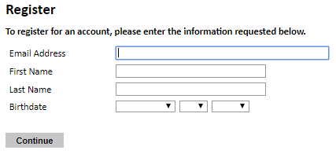
Note: Use an email address that you will be able to access for at least two years after submitting your application. This is the email address you will use to log in to your application account. We recommend you do NOT use a work email address if you will not have access to it during your grant in the U.S.

- Click Continue. You will receive an email from apply@iie.org confirming that you have started the application. The email will include a temporary PIN. Follow the instructions in the email to activate your account using the temporary PIN.

- You will be prompted to enter your pin and then create a password to complete login.

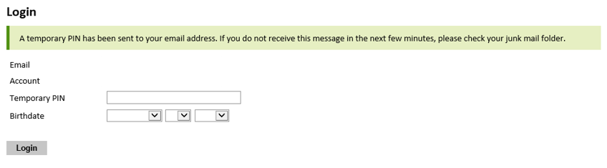

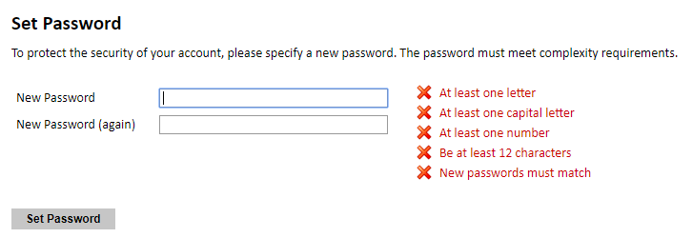

- Returning users: Click Log in and enter your email address and password. If you do not remember your password, click Forgot your password? and follow the resulting instructions.

Managing Your Application

Editing your application prior to submission

- You may log in at any time to review and edit your application form, upload documents, and enter recommender information.
- Remember to save your application after completing each page by pressing the Continue button at the bottom of each page.
Note: The application will automatically log you out after 60 minutes of inactivity, so it is best to save your application frequently.

Reviewing your application after submission
- After you SUBMIT your application, you CANNOT make any changes.
- You may continue to log into your account to view the information you have submitted, save a PDF of your application form, and manage your recommenders.
- You can manage your recommenders by clicking on the Recommendations section of the online application.

letters of recommendation

- Letters of recommendation will be submitted directly to Fulbright by the recommenders you registered via your application.
- Letters of recommendation and language evaluations may be submitted before or after you submit the application.
- If your recommender is unavailable, you will have the option to exclude the recommender and add an alternative after you submit the application.

Preliminary Questions

These questions address essential program eligibility. All questions are required.

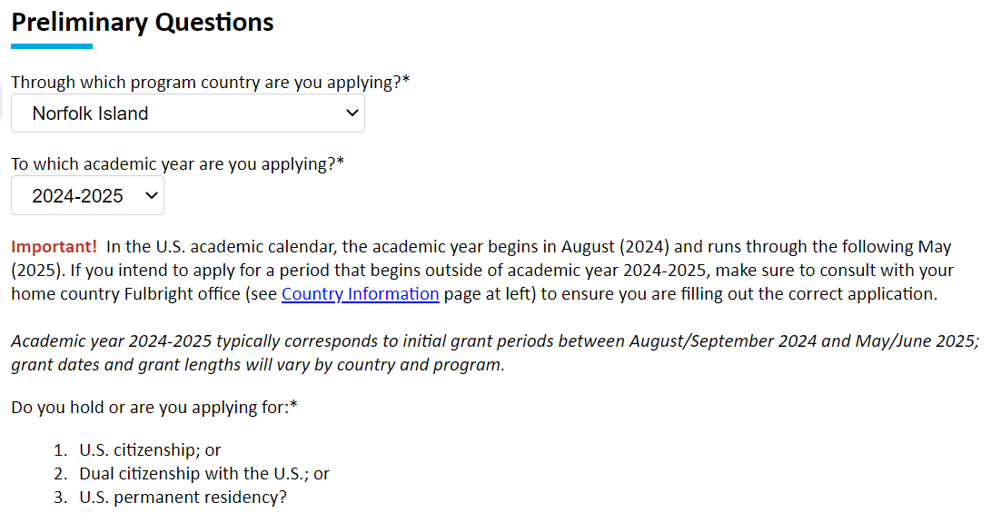

- Select the country through which you are applying for the Fulbright grant from the drop-down menu.

- Select the 2024-25 program year from the drop-down menu.

- U.S. Citizenship, Dual Citizenship with the U.S. or Permanent Residency: select ‘Yes’ or ‘No’ to indicate your response.
  - Applicants cannot be U.S. citizens or permanent residents of the U.S. to participate in the Fulbright Foreign Student Program.

- Select ‘Yes’, ‘No’, or ‘unsure’ to indicate if you are aware of, and meet, all program eligibility requirements.
  - Please review the program eligibility requirements for the country through which you are applying before proceeding.

- Carefully review the Data Privacy information. If prompted, indicate your acceptance of data privacy terms by selecting ‘Yes’ or ‘No’.
  - You will not be able to submit your application without indicating your agreement to the Data Privacy terms.

- Select ‘Yes’ or ‘No’ to indicate if you meet all employment eligibility requirements.
  - Applicants or applicants’ immediate family cannot have been employed by the stated organizations and/or agencies within the year prior to application.
  - If you select ‘Yes’, please provide details of employment or association.

- Select ‘Yes’ or ‘No’ to indicate whether you waive your right to review the information contained in the evaluations submitted by recommenders on your behalf.

- Click Continue to save your responses and advance to the next section.

Country Information

- Review all information in this section!

- Note any country-specific and award-specific instructions for completing the rest of the application, including:

  - Country website
  - Deadline information
  - Open application cycle
  - Additional required materials

- You must select an Award before proceeding.

- Click Continue to proceed to the next section.

Personal Information

Enter all required biographical information. Please review country-specific guidance (provided in the Country Information section of the application) to determine whether you must provide additional information or documentation.

- Enter your name exactly as it appears on your passport. Only enter a preferred first name if it is DIFFERENT than your legal name (e.g. Alex instead of Alexander).

- If your name is recorded differently on any previous records, list the variation in the Name on Previous Records section (e.g. maiden name).

- The birthdate that you used to create your account will automatically appear. If you entered this date incorrectly during your account creation, you may correct it now.

- Enter your city of birth and select country of birth, sex (as it appears or will appear on your passport or travel document), preferred gender identity, and marital status from the drop-down menus provided.

- List any form of limitation that may require accommodation.

- Select your country of citizenship and country of residence from the drop-down menus provided.

- If applicable, enter your national identification number and any additional countries in which you hold citizenship.
  - To select multiple countries, hold down the CTRL (PC) or Command (Mac) button when selecting options.

- Click Continue to save your responses and advance to the next section.

Contact Information

Enter all required contact information. Please review country-specific guidance to determine whether you must provide additional information.

- Select the country where you live from the drop-down list first when entering your permanent address (i.e. physical address where you live).
  - Based on your country selection, the subsequent fields will change to match the address format of that country.
  - Complete the remaining address fields. Do not use accents or special characters.

- Select ‘Yes’ or ‘No’ to indicate if your current mailing address (i.e. the address where you receive mail) is the same as the permanent address you entered above. They do not have to be the same.
  - If you answer ‘No,’ then a second address section will appear where you may enter your mailing address information.
  - If you answer ‘Yes’ to this question, proceed immediately to the next question.

- Enter your contact numbers, including the country code. If the field turns red, please review the numbers that you have entered to identify any errors.
  - To find the correct country code, click on the blue ‘country code’ link.
  - Make sure to provide a mobile phone number, it is country-specific requirement.

- The email address used to create your account will appear in the primary email address field and will not be editable. You may provide an Alternate/Secondary Email that can be used to contact you if Fulbright Program Officers cannot reach you via your primary email address.
Note: All system-generated emails will continue to go to your primary email address.

- Enter your home country emergency contract information. The individual(s) you list may be contacted in the event of an emergency while you are participating in grant activities, including any required travel for interviews in your home country.
  - When entering the address, choose the country first and the following fields will update to match the address format of the selected country.

- Entering emergency contact information in the United States is not required. If you have emergency contact(s) in the United States at this time, please enter the appropriate information.

- Click Continue to save your responses and advance to the next section.

Academic & Professional Information

This section collects information about your academic and professional background, including your curriculum vitae/resumé, academic degrees, professional experience, awards and recognitions, and experience abroad.

Prepare and upload documents in PDF format as required (*). Note any page limits and ensure your documents do not exceed page limits.

Curriculum Vitae/Resume
- Upload your curriculum vitae/resumé in PDF format that does not exceed four (4) pages.
Note: If your file exceeds 4 pages, an error message will appear.

- Click Choose File
- Locate and select the file that you previously saved to your computer
- Click Open
- Click Upload to complete the file upload

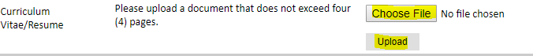

Academic Background

- List all post-secondary educational institutions you have attended for credit-bearing coursework, in reverse chronological order (going backwards in time), including any in which you might be presently enrolled. Do not include any short-term certificate programs, which should be noted on your CV/Resume. You MUST include any education institutions you are currently attending (even if you have not yet completed your educational program) and estimated date of graduation/completion.

  - Click Add New Academic Background
  - Type in the name of the institution
  - Choose the level of study (graduate or undergraduate) from the drop-down menu
  - Select the country where the institution is located from the drop-down menu
  - Enter the appropriate city and region/state
  - Provide the website of the institution (optional)
  - Select the U.S. equivalent of the degree or diploma earned (e.g., BA – bachelor’s degree)
  - Enter the discipline in which this degree or diploma was earned
  - If relevant, provide the actual name of the degree or diploma (e.g., master’s)
  - Enter your final cumulative Grade Point Average, as noted on your transcripts or diploma
  - Enter the highest possible Grade Point Average at your institution (ex: 4.0)
  - Select the month and year of start and end dates (Month – Year format) that you attended this institution
    - If a degree is in progress, list expected end date of academic program
  - Select the date (Month-Year format) that you received your degree from this institution
    - If a degree is in progress, list expected date of conferral in this field
  - Click Save.

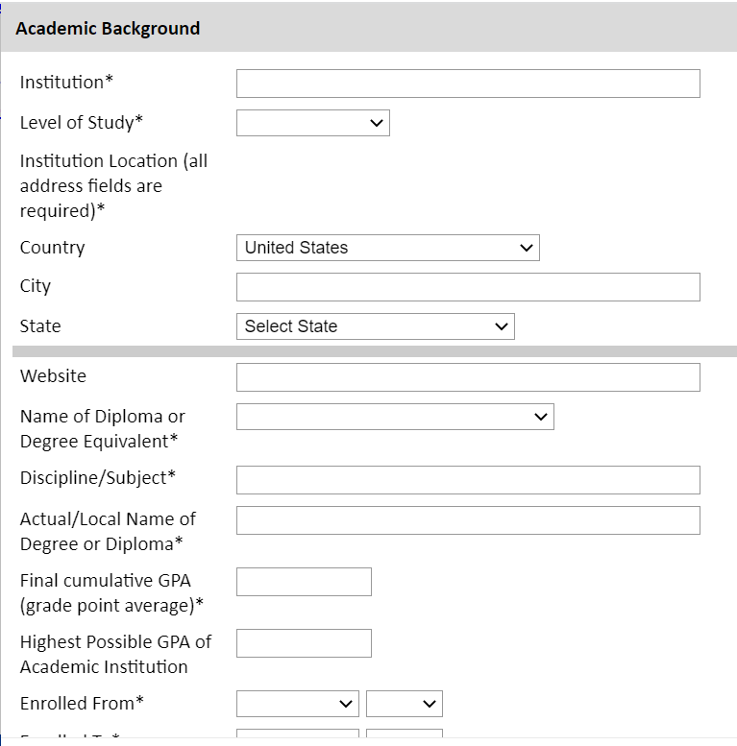

- To add additional entries for post-secondary educational institutions, click Add New Academic Background and follow the bulleted instructions above.

Professional Experience

- List your current professional affiliation or employer and any relevant previous professional experience by clicking Add New Professional Experience under Position Title.

  - Choose the role which most closely corresponds to your current role and/or relevant previous professional work experience from the drop-down menu
  - Enter position title (e.g. Director, Assistant Director, etc.) or type of work (e.g. accounting)
  - Enter the name of your employer
  - Select the start and end dates for the position you entered (Month-Year format). If you are currently employed in this role, leave the End Date fields blank
  - Select the country where your current place of employment is located from the drop-down menu. Enter in the street address, city, state/region, and post code as applicable
  - Click Save

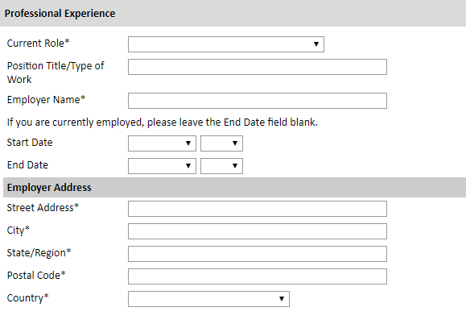

- If you have more than one current position and/or relevant previous professional experience, click Add New Professional Experience and follow the instructions above.

Awards and Recognitions

- Enter a list of the following items into the text boxes provided (all text boxes have a 250-word limit). If you do not have anything to add, leave text boxes blank:
  - Any current or previous scholarships and/or fellowships awarded to you (include the source or sponsor, amount, where held and duration)
  - Any academic honors and prizes that you have received (include any titles and/or dates)
  - Any books, articles, and/or thesis published by you, particularly in your proposed field of study (include the title, place, and date of publication)
  - Any teaching experience (current or previous positions); this is especially relevant for PhD candidates and candidates in the field of education
  - Any research you have completed or in which you are currently involved
  - Any memberships in professional organizations, or licensing obtained by a professional organization
Do not upload into the application any appreciation or completion certificates, letters, diploma projects, articles, or book chapters you published.

Experience Abroad

- List any travel, study or residency you have had abroad (in any country other than your own) for more than one month. This can include time overseas for education, research, business, vacation, etc.
  - Click Add New Experience Abroad
  - Select the country in which you spent your professional travel and/or residence abroad from the drop-down menu provided
  - Select the start and end dates (Month-Year format) of you travel/residency
  - Enter the purpose of your travel abroad
  - Click Save

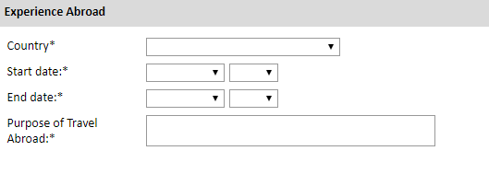

- If you have more than one trip abroad to enter, click Add New Experience Abroad again, and follow the bulleted instructions until all entries have been saved.

- Select ‘Yes’ or ‘No’ to indicate if you have previously entered the United States on a J-1 or J-2 visa

  - If ‘Yes’, you are required to select the J category of sponsorship from the list and upload a copy of your previous DS-2019

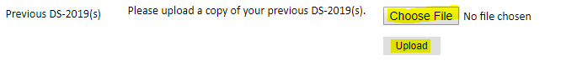

- Select ‘Yes’ or ‘No’ to indicate if you have previously been awarded a Fulbright grant.
  - If ‘Yes’, you are required to list the grant(s):
    - Select the number of previous Fulbright grants you would like to add
    - Select the Fulbright award type from the drop-down menu provided (e.g., Fulbright FLTA, Fulbright Foreign Student, etc.)
    - If you select “Other (please specify)”, enter in the name of the Fulbright grant that you received in the “Other, please specify” field
    - Select the academic year that corresponds to the year in which you received the Fulbright grant
    - Click Save

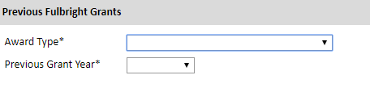

- Click Continue to save your responses and advance to the next section.

Academic Materials

This section collects copies of your unofficial transcripts and/or diplomas. Please upload into your application scans of notarized copies of transcripts and diplomas from all post-secondary education institutions you have attended along with certifies English translations.
If required, or if no additional guidance is provided, please upload scans of all available transcripts and diplomas from post-secondary institutions you have attended.
- Select the corresponding institution from the list of institutions you previously entered.

- Review the institution information (which you provided on the previous page). If this information is incorrect, you can edit the information directly in the popup box.
  - If you do not see an institution that you attended below, you may either return to the Academic & Professional Information page and update your academic background or add the institution by clicking the "Add Institution" link.

- Select Choose File and locate the desired file on your computer. Click Open.
  - You may upload transcripts/diplomas as a multi-page documents or upload single page documents. PDF, JPEC, and TIFF image files are all accepted.

- Click Save. Repeat these steps for all applicable institutions.

- Click Continue to save your responses and advance to the next section.

Language Skills

This section collects information about your native language, English language skills, and any additional languages that are relevant to your project proposal.

- Select your native language from the drop-down menu provided.

English Language Proficiency
If your native language is not English, a section collecting your English language proficiency will appear.

- Rate your English language proficiency in Reading, Writing, and Speaking. Select Native, Advanced, Intermediate, Beginner or No Ability from the drop-down menus as appropriate.

Additional Language Skills

- Select the number of additional languages that you would like to include that may be of use for your project or study plans.

- Select the language you are reporting from the drop-down menu and rate your proficiency in Reading, Writing, and Speaking. Select Native, Advanced, Intermediate, Beginner or No Ability from the drop-down menus as appropriate.

- Click Continue to save your responses and advance to the next section.

Standardized Test Scores

This section collects information about standardized test scores that you have taken or will take in the future. Standardized tests include TOEFL, Duolingo, GRE, GMAT, IELTS, MCAT and LSAT. Standardized test scores are often required for admission to U.S. institutions.
- Select Add Test.

- Select the test type from the drop-down menu.

- Select the test date from the drop-down menu (Month-Day-Year format).
  - If you have not yet taken the test, enter the date that you are registered for the test.

- Enter your test scores, if you have the results from the test.

- Click Save. Repeat these steps for all applicable standardized tests.

- Click Continue to save your responses and advance to the next section.

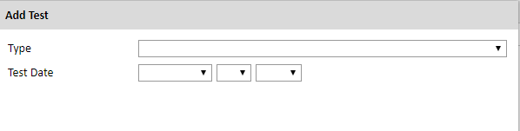

Score Reports

- If you enter test scores, you will be redirected to the Score Reports section, where you will upload copies of your available score reports.
  - Click Choose File
  - Locate and select the file that you previously saved to your computer
  - Click Open
  - Click Upload to complete the file upload

Plagiarism Agreement

- Carefully review the Plagiarism Agreement and indicate your acceptance of the terms by selecting ‘Yes’ or ‘No’.
  - If you select ‘No’ you will receive a warning message and you will not be able to submit your application.
- Click Continue to save your responses and advance to the next section.

Study Plan
This section collects information about your proposed plan of study in the U.S. Please carefully review country-specific guidance to determine if you must submit any additional documentation.

- Select the degree objective to which you are applying.

- Select the most appropriate major academic discipline and primary specialization from the drop-down menus.
  - Some fields, such as Arts and Architecture, will trigger a message that you are required to upload portfolio materials as part of your application. You will be able to upload materials on the next page.

- Enter a brief description of the field in which you plan to specialize in the United States in the text box.

- Enter a description of your future plans in the text box.

Intended Grant Period
- Enter your proposed length of stay in the United States and select your proposed date of arrival in the United States (Month-Day-Year format) from the drop-down menu. Typically, degree-seeking students will begin in August/September of the proposed academic year.

Study/Research Objective
- Upload a copy of your study/research objective. Please write a clear and detailed description of your study/research objectives and provide your reasons for wanting to pursue them. This statement is an essential part of your application and is required. Do NOT mention specific U.S. universities at which you would like to study. The essays should not exceed 2 pages.
  - Click Choose File
  - Locate and select the file that you previously saved to your computer
  - Click Open
  - Click Upload to complete the file upload

Personal Statement

- Upload a copy of your personal statement. Your personal statement should be a narrative statement describing how you have achieved your current goals. Do not mention specific U.S. universities at which you would like to study. This is a required document and should not exceed 2 pages.
  - Click Choose File
  - Locate and select the file that you previously saved to your computer
  - Click Open
  - Click Upload to complete the file upload

Writing Sample

- Upload writing sample. This is required for all PhD (Doctoral) applicants. Select Master’s fields may also require a writing sample. If no specific guidance is provided in the country instructions, and you are not a PhD applicant, then this field is recommended, but not required.
  - Upload a writing sample, only if prompted as a requirement based on degree objective and/or field of study. Click Choose File
  - Locate and select the file that you previously saved to your computer
  - Click Open
  - Click Upload to complete the file upload

Letter of Invitation

- Upload a letter of invitation from a U.S. institution, if your intended degree objective is Visiting Student Researcher and you have received one. This is NOT a requirement. As applicants from Kazakhstan should choose master’s degree objective, no invitation letters are required for them.
  - Click Choose File
  - Locate and select the file that you previously saved to your computer
  - Click Open
  - Click Upload to complete the file upload

University Preferences

- List up to four (4) institutions at which you would like to study in the U.S. in priority order. Include specific departments and/or programs and provide specific reasons for your choice. If you have been in contact with professors, please provide names and email and/or phone contacts for each one.
Note: There is no guarantee that your application will be sent to the institutions that you list. Applications are made on your behalf to programs that provide a good ‘academic fit’ based on your study plans and your competitiveness.

  - Enter institution name
  - Enter name of department
  - Enter the degree type and academic program that you are interested in at this institution
  - Enter your preferred specialization or concentration within the academic program
  - Enter your specific reasons for listing this institution and any contact information for professors at the institution with whom you have already communicated
  - Click Save

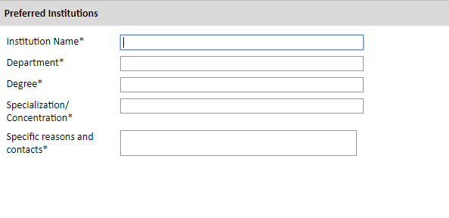

Applied U.S. Institutions

*If you have previously applied or intend to apply to a U.S. Institution, please complete this section. Otherwise, move to the Authorization of Release of Information.

- Select the number of U.S. institutions to which you have applied from the drop down menu:
  - Enter name of institution
  - Enter specific name of department
  - Select the date you applied for the institution (Month-Day-Year format)
  - Enter the term you applied for
  - Enter year you applied for
  - Select the result of your application from the drop down menu
  - Select ‘yes’ or ‘no’ to indicate if you are still interested in pursuing this program

Authorization of Release of Information

- Type your full name into the space provided to indicate your authorization of release of the information you have provided in this application.

- Click Continue to save your responses and advance to the next section.

Grant and Travel Plans

Financial Information
This section gathers information on your personal finances, additional funding you may have applied for/received, passport, and accompanying dependents. Please note that these sections may not be required if you are from certain countries. Review country-specific information before completing. Applicants from Kazakhstan are not required to provide information on personal or family finances, additional funding from other sources expected. Leave these sections blank.

Family Funds
- Enter your parent(s) and spouse/legal partner’s occupations in the corresponding boxes.

- Enter the total amount your family can provide for your first year of study in the U.S. (in USD).

- Enter the total amount you can provide from your own funds for your first year of study in the U.S. (in USD).

Expected Additional Funding
List all non-Fulbright funding you expect to receive during your grant.

- Select ‘Yes’ or ‘No’ to indicate if you have been awarded or expect to receive financial assistance from a university or institution in your home country while in the U.S., or funding from any other sources.
  - If ‘Yes’, select the number of other sources of funding you expect to receive
    - Enter Source Description (e.g., NSF grant)
    - Estimated Amount (in USD)
    - The Other Funds Total field will automatically update based on the amounts provided above

- Indicate if you are planning to apply for, or have applied for and/or received, other sources of funding such as a fellowship, assistantship, or other educational grant or loan from another organization, government or educational institution. Include funding title, source, period of funding, and amount of funding for which you are applying, and if/how this project relates to Fulbright project. If additional funding is received after Fulbright application is submitted, please update Fulbright administration. Maximum 1000 characters.

- Select ‘Yes’ or ‘No’ to indicate whether the same amount of funding you listed above in Grand Total will be available for your second year of study in the United States.
  - If yes, move to the next section
  - If no, enter the amounts of any additional funding you expect for the second year

- Select ‘Yes’ or ‘No’ to indicate if you have travel funds available and can pay for your round-trip travel to the United States if necessary.
  - If ‘Yes’, enter the amount of travel funding available
  - If ‘No’, move to the next section

Passport/Travel Document and Dependents

- If required, upload a copy of your passport or travel document.
  - Click Choose File
  - Locate and select the file that you previously saved to your computer
  - Click Open
  - Click Upload to complete the file upload

- Select the number of dependents you intend to have accompany you to the U.S. (select 0 if you do not have dependents or your dependents will not accompany you to the U.S.).
  - Enter required information for each dependent, including relationship to you, name, and intended length of stay in the U.S. (in number of months)
  - Enter information for how you will provide for your dependents during your time in the U.S. in the text box

- Click Continue to save your responses and advance to the next section.

Additional Information
Use this section to upload any required additional documentation per your country-specific guidance.

Complete the Outreach Survey.

Click Continue to save your responses and advance to the next section.

Recommendations

Use this section to register your recommenders. Applicants from Kazakhstan are required to submit 3 recommendations. Do not submit more than 3 recommendations.

Once you register your recommenders, they will receive an automatic email with instructions on completing the online recommendation form. You can track the status of recommendations, send reminders, and add/delete recommenders through this system before and after submission of your application. Letters of recommendation must be submitted directly by your recommenders either via the online application or emailed directly by your recommenders to your Fulbright Program Office.

- Click Add Recommender.
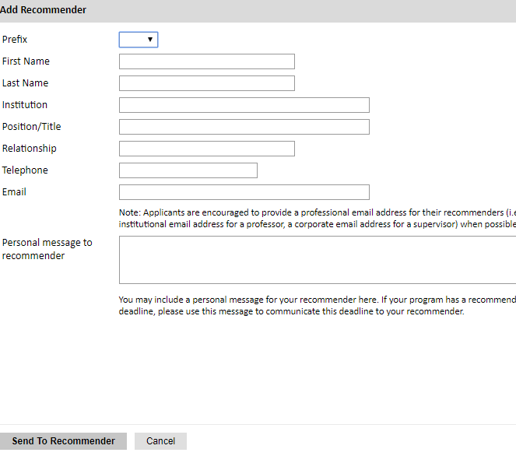
- Complete all fields in the pop-up form:

Click Send to Recommender to generate automatic email to recommender.
- Click Continue to save your responses and advance to the next section.
- Once sent, you will have the option to Edit Recommender information if they have not yet started progress on their response and Save, Send Reminders, and Exclude if you wish to remove the recommender and replace with another individual.

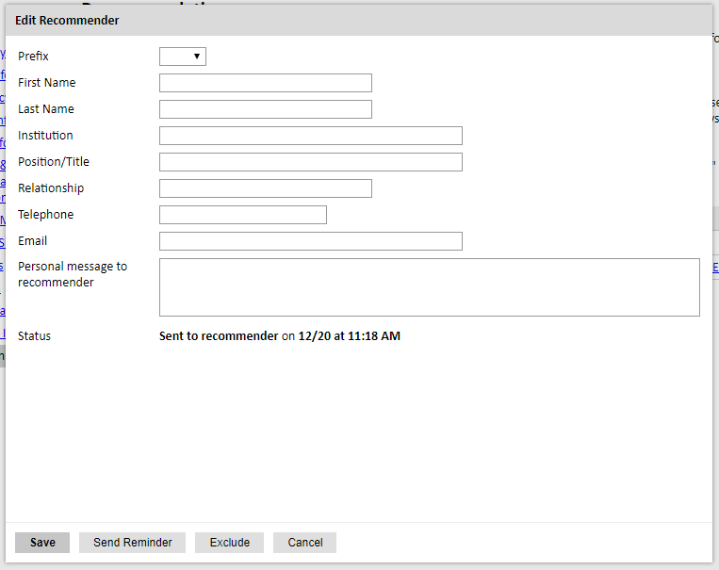

Signature

Certify that the information you provided in the application is true and complete by typing your full legal name in the Signature Box:

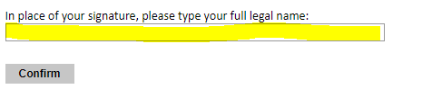

Click Confirm to continue to the next page.

Review

The application will review the responses entered and will display any incomplete questions and required attachments that are missing.
• If no errors appear, then your application is ready for submission.

• If any errors appear, correct or complete these sections and return to the Review section to determine if your application is ready for submission.

REVIEW ALL RESPONSES. CLICK SUBMIT.

